Workflow in Cinema4D
Set up the reconstruction and created a structure using “null objects” to group the architectural elements. The structure follows the suggested hierarchy | 3
Started to lay the basis for the reconstruction. For this, the reference images were inserted, placed and scaled. | 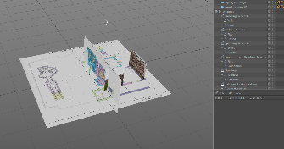
Reconstruction of the round windows. Use of the report, reconstruction drawing and photos for the dimensions. Reconstruction with the help of, cylinders and a cone shape
Reconstruction of the windows from the north and south sides. Here, only the report could be used for the dimensions because no remains are left today. Reconstruction with the help of Booleans, square and cylinder shapes.
The western windows still exist, so the photo could be used as a reference. The window-shape from the north/south windows was used as a basis. The column was built with spline-modelling combined with primitive objects that are connected into one object. | 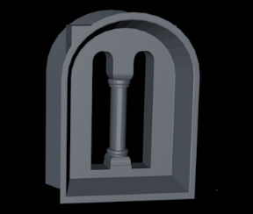
Reconstruction of the walls. The course of the walls was determined with help of the report and the reconstruction drawing. The walls were built with help of box-modelling. The Knife tool was then used to cut out the existing parts of the wall. They were split into two objects and the holes closed with the bridge tool. Photos and reconstruction drawings were used as references for cutting. | 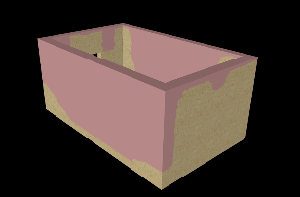
Analogy_02 was used as reference. The doorway is built out of several objects that are connected into one. The columns were built with several cubes and cylinders that were connected into one object. The frame was built out of connected cubes. The arch was built with help of splines and two sweep generators. | 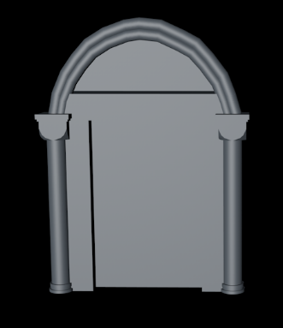
The openings for the windows and doors were cut out with the knife tool and the corresponding openings were inserted and scaled if necessary to match the dimensions of the walls. Photos and reconstruction drawings were used to place the windows and doorway. | 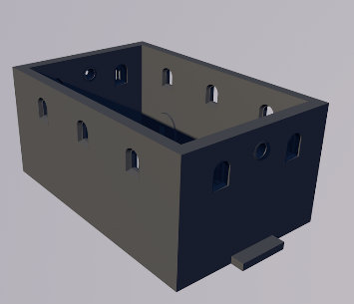
The Aron Hakodesh was reconstructed out of several parts. The base and roof were built with cubes and knife tool. The columns were reused from the doorway and scaled to fit the dimensions of the Aron Hakodesh. In the end, the parts were connected into one object. | 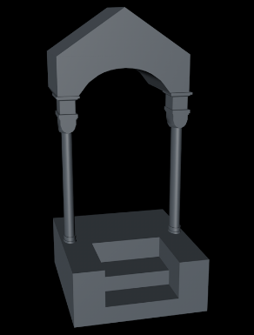
The floor was reconstructed on the basis of the report drawing. For this, a plane was placed on the floor level and cut out with the knife tool along the remains of the floor which are visible on the drawing. These parts were separated and made into two different objects. | 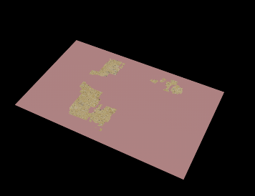
Parts of the cornice are still visible today. The rest could be reconstructed on the basis of the report drawing. The walls were cut with the knife tool and the new polygons extruded to create the cornice. | 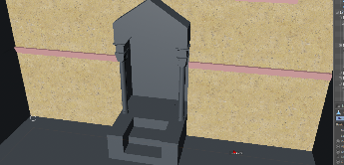
There are no remains of the roof, so it was reconstructed according to the rules of a hipped roof. Several cubes were positioned 3to form a hipped roof. These cubes were then combined into one object | 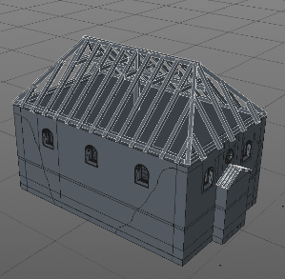
The roof was modelled to fit the beams. First a cube was fit to the desired size and placed according to the beams. With the knife tool the shape of a hipped roof was cut out. Lastly a boole-generator was used to hollow out the roof. | 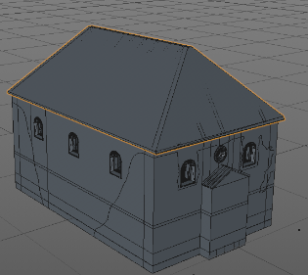
The modelling of the foundation was part of the reconstruction of the walls. This part was then detached from the walls (split tool) and renamed accordingly. | 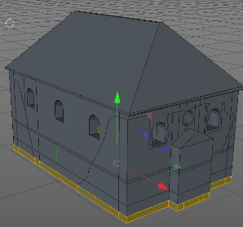
Lastly the reconstruction structure was checked and the elements named according to their certainty levels. | 