Ground plan and Walls

Reconstruction | 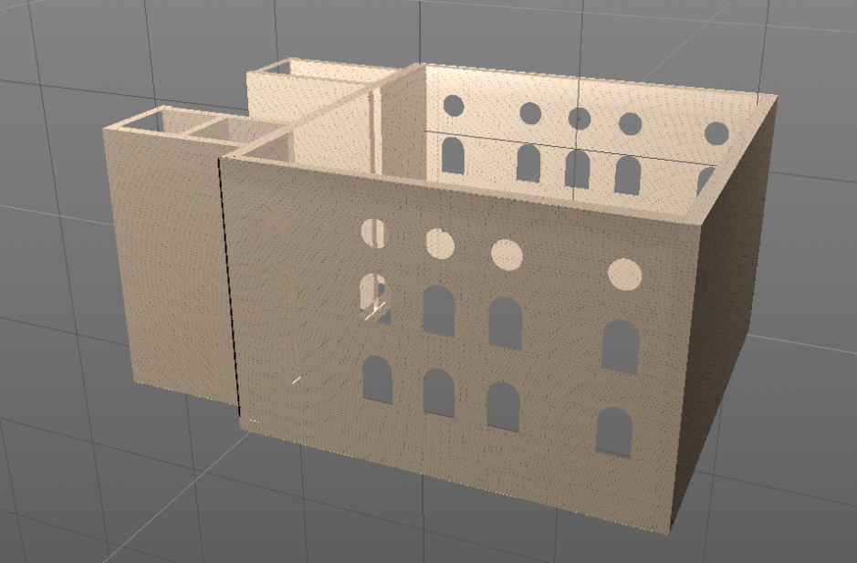
Used sources | Drawing_01  Drawing_02  Drawing_03  Drawing_04  Picture_01 | 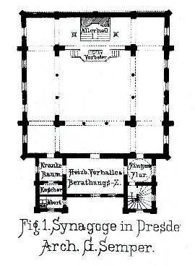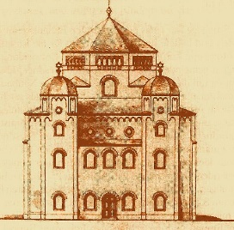
Uncertainty | There are no fragments of the whole Synagogue. Due to there is no picture or drawing of the western (here right side) wall, there is no information about possible windows. | 2/3
Argumentation | On the basis of the preserved construction drawings it is possible to reconstruct the walls and the window openings.

Windows
Reconstruction | 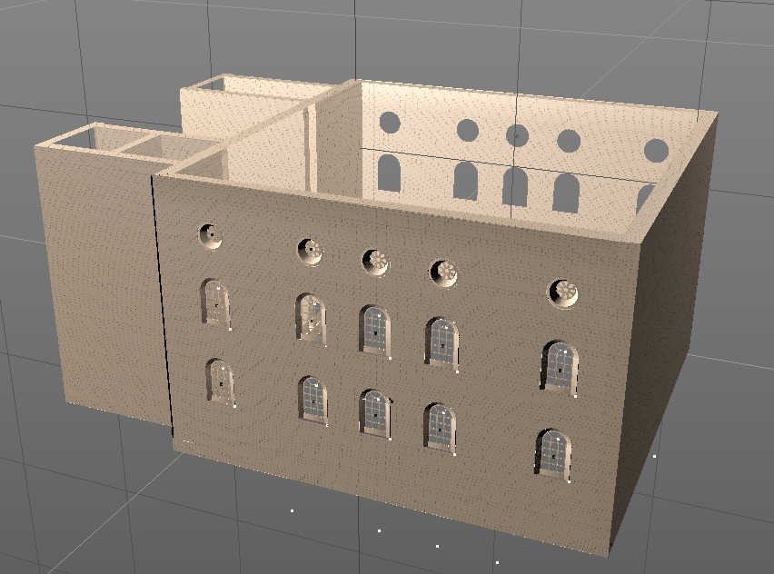
Used sources | Drawing_01  Picture_01  Photo_01 | 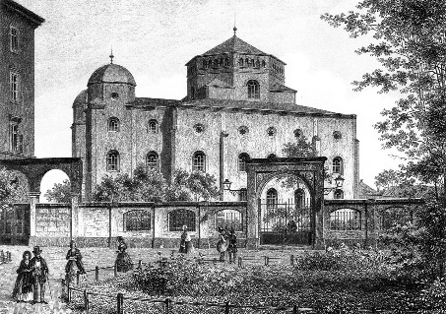
Uncertainty | No Fragents; dark Pictures | 3/2
Argumentation | There is a good Drawing with Picture_01 to reconstruct the diverse window.

Tower
Reconstruction | 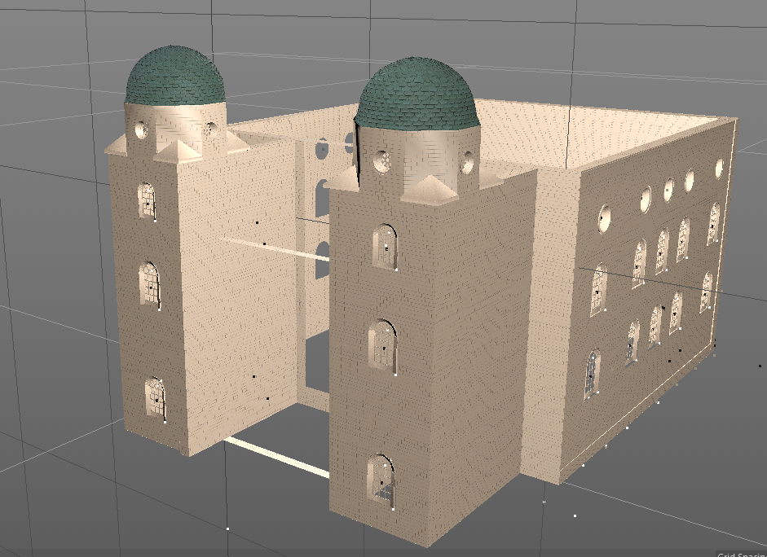
Used sources | Drawing_01  Drawing_04  Photo_02  Photo_03  Picture_01  Picture_02 | 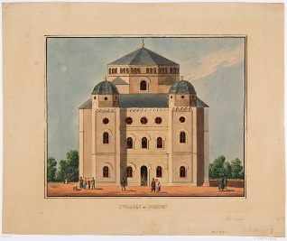  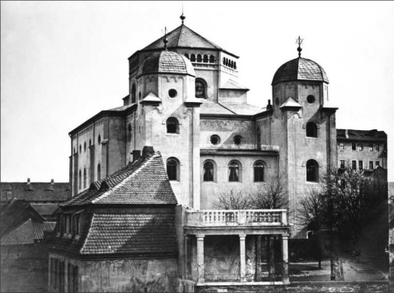
Uncertainty | Structure of the tower dome | 3 / 2
Argumentation | It was reconstructed with the greatest similarity to the photos and drawings.

Star of David
Reconstruction | 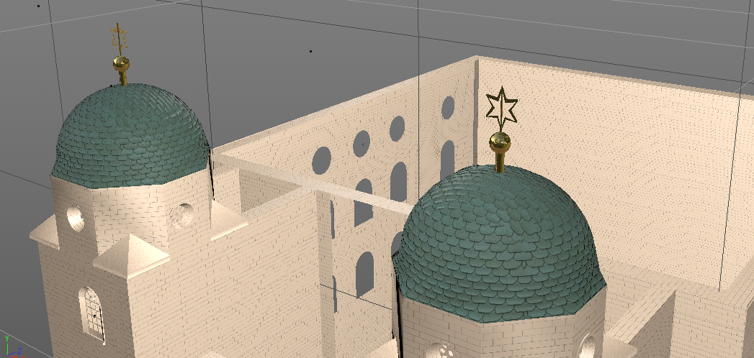
Used sources | Photo_3
Uncertainty |  | 3
Argumentation

Anterooms with Roofs
Reconstruction | 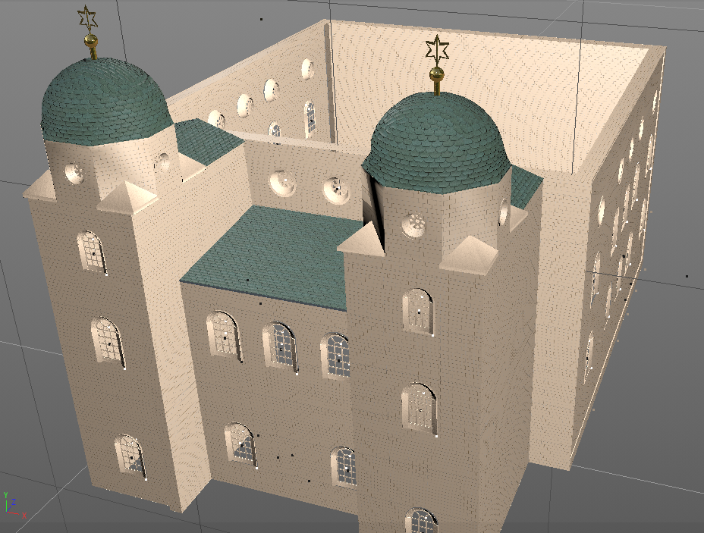
Used sources | Drawing_01  Drawing_02  Drawing_04  Picture_02 | 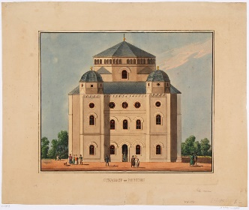
Uncertainty |  | 3
Argumentation

Roof of the Main room
Reconstruction | 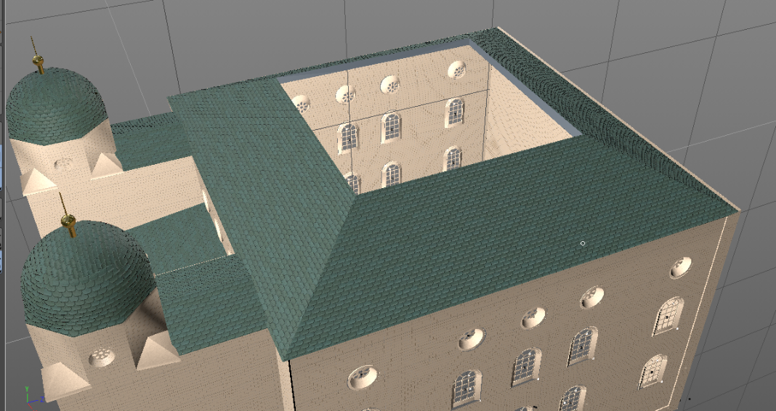
Used sources | Picture_04 | 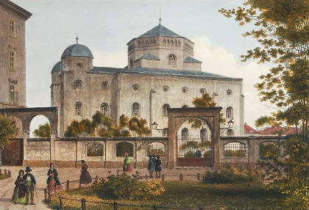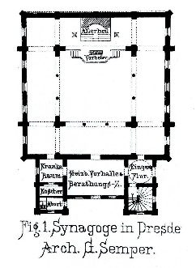
Uncertainty | There is no good view on the roof. | 3 / 2
Argumentation | With help of the floor plan and the diverse Pictures it is possible to reconstruct the position of the roofs.

Main Dome
Reconstruction | 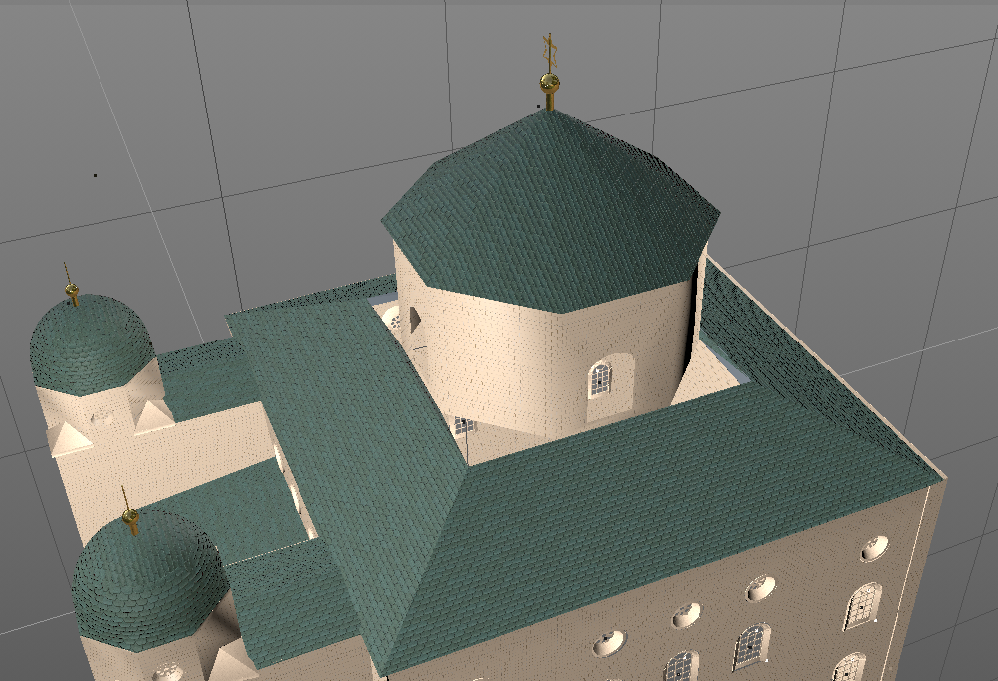
Used sources | Drawing_01  Drawing_04  Picture_01
Uncertainty |  | 3
Argumentation

Main Dome
Reconstruction | 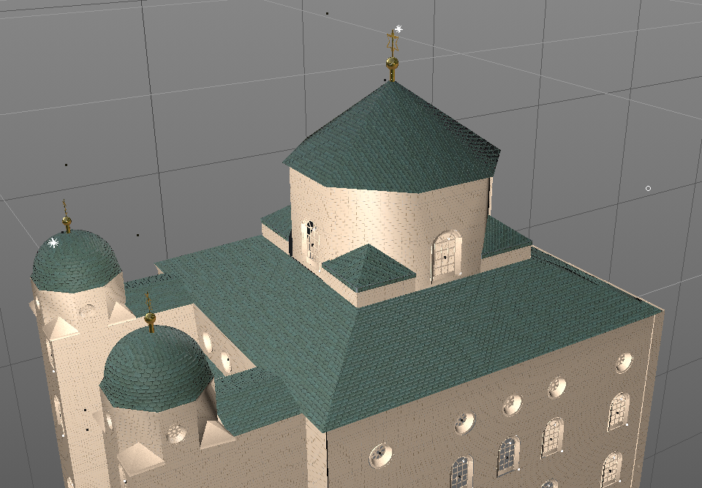
Used sources | Drawing_01  Drawing_04  Picture_01
Uncertainty | Windows | 3
Argumentation | See “windows”

Drawing_01 Kerstin Hagemeyer: Jüdisches Leben in Dresden. Ausstellung anlässlich der Weihe der neuen Synagoge Dresden am 9. November 2001. SLUB Dresden, Berlin 2002, S. 69 Ansicht der Neuen Synagoge zu Dresden, Allgemeine Bauzeitung 12 (1847).- Blatt 105

Drawing_02 Die Bauten, technischen und industriellen Anlagen von Dresden, Von Sächsischer Ingenieur- und Architekten-Verein, Dresdener Architekten-Verein · 1878

Drawing_03 Die Bauten, technischen und industriellen Anlagen von Dresden, Von Sächsischer Ingenieur- und Architekten-Verein, Dresdener Architekten-Verein · 1878

Drawing_04 Die Bauten, technischen und industriellen Anlagen von Dresden, Von Sächsischer Ingenieur- und Architekten-Verein, Dresdener Architekten-Verein · 1878

Photo_01 Unknown Author, VEB Foto Erlbach i. Vogtl. Fotosammlung

Photo_02 Unknown Author, Sächsische Landesbibliothek, Staats- und Universitätsbiblothek ⁣SLUB Dresden Blog: "Zum Gedenken an den 80. Jahrestag der Novemberpogrome" (slub-dresden.de)

Photo_03 Unknown Author, Bildarchiv Foto Marburg, https://www.bildindex.de/document/obj20161484

Picture_01 Lithograhpie by Ludwig Thümling (around 1860)

Picture_02 Unknown Author, colored etching (around 1860) https://skd-online-collection.skd.museum/Details/Index/1246706

Picture_03 Künstlerpostkarte: Verlag Schneider & Co., Altenburg ca. 1920, Maler: Hermann Wunderlich (1839 - 1915)

Picture_04 Colored engraving by Lduwig Thümling (around 1865)

