Window_a

Reconstruction | 33
Used sources | Report_text_page_11 | 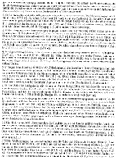
 | Report_drawing_05  Photo_location_10 | 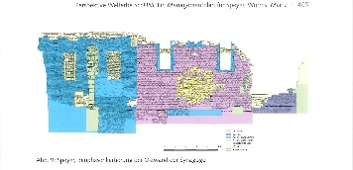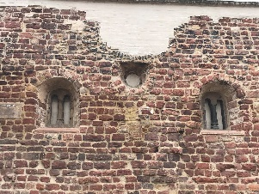
Uncertainty | The Windows are still existing and therefore the level of certainty for the reconstruction is on the highest level | Level 4
Argumentation | Report_drawing_05 as well as the description in the report (page 11) were used as the basis for the reconstruction. Drawing and report do not give information about all dimensions of the window. Therefore photo_location_10 was used as a reference.
Window_b

Reconstruction
Used sources | Report_text_page_11
Uncertainty | These windows no longer exist. There are also no imprints or similar on the walls, so that their shape or position cannot be deducted. | Level 2
Argumentation | The dimensions were taken from the report

Window, east and west

Reconstruction
Used sources | Report_text_page11 | 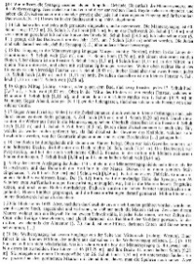
 | photo_museum_01 | 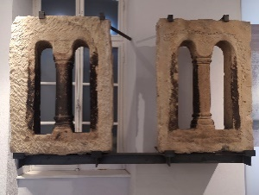
Uncertainty | The western windows are still existing. The windows on the eastern wall are reconstructed similarly and therefore only level 3 in certainty | Level 3/4
Argumentation | The photo from the museum could be used for reconstructing the shape and the report could be used for the correct dimensions.

Walls_a

Reconstruction | 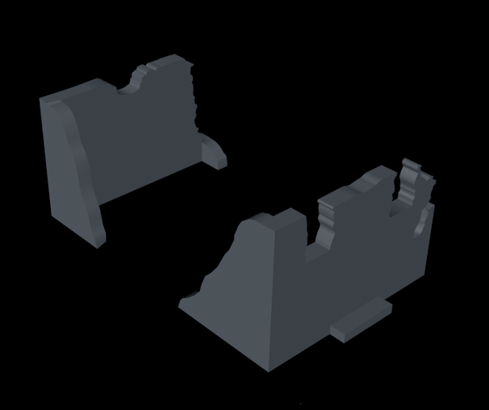
Used sources | report_drawing_05  report_drawing_03 | 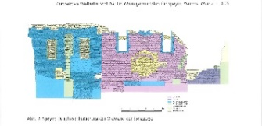  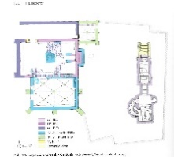
 | photo_location_02  photo_location_03 | 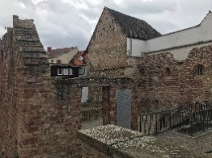  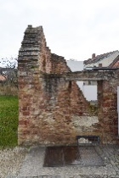
Uncertainty | Still existing | Level 4
Argumentation | The dimensions were taken from the report and the photos
Walls_b

Reconstruction | 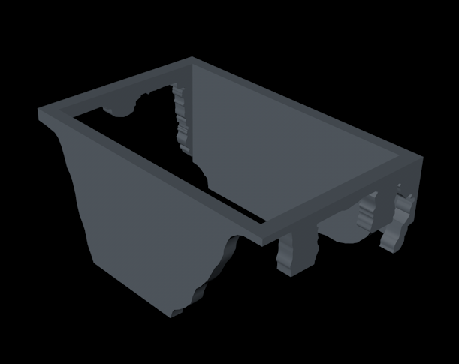
Used sources | report_drawing_05
 | report_drawing_03
Uncertainty | Reconstruction on the basis of the still existing parts of the wall | Level 3
Argumentation | The dimensions were taken from the report drawings and the photos

Door

Reconstruction | 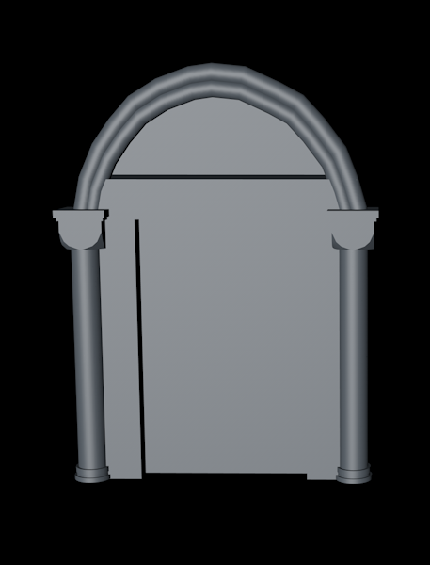
Used sources | analogy_02_01 | 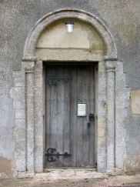
 | report_drawing_03
Uncertainty | The door does not exist anymore, therefore a analogie had to be used | Level 2
Argumentation | Analogy_02 was used as reference because it has a relatively simple shape. The report drawing was used for the dimensions.

Floor_a/b

Reconstruction | 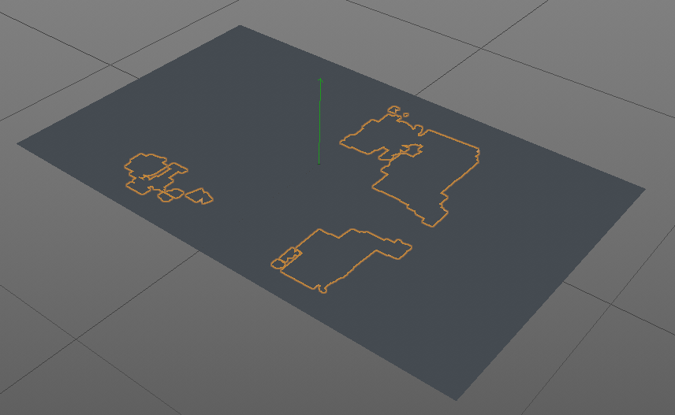
Used sources | report_drawing_03
Uncertainty | The report drawing shows the still existing parts of the floor. The rest could then easily be deducted | Level 4/33
Argumentation | The report drawing could be used to reconstruct the existing and missing part of the floor

Aron Hakodesh

Reconstruction | 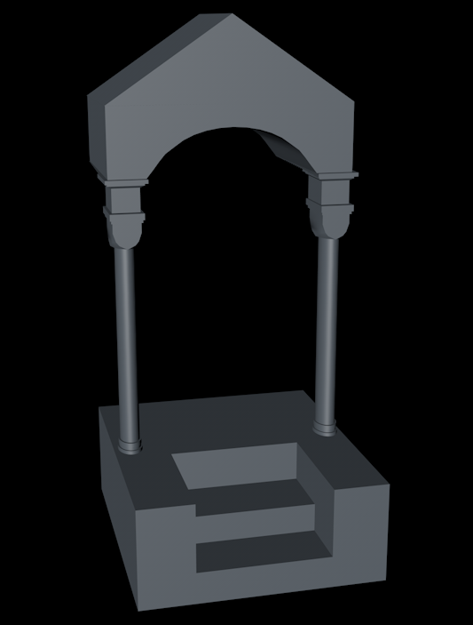
3Used sources | report_drawing_05  Photo_location_05 | 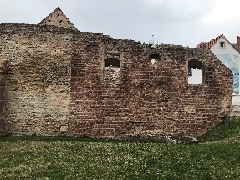
 | article_01_Page183_Abb18
Uncertainty | Only the general shape and location is visible on the eastern wall. The rest had to be deducted from analogies | Level 2
Argumentation | The reconstruction was based on analogies of similar structures from the defined time period. The dimensions were scaled to fit the niche which is visible on the report drawing and photo.
Cornice

Reconstruction | 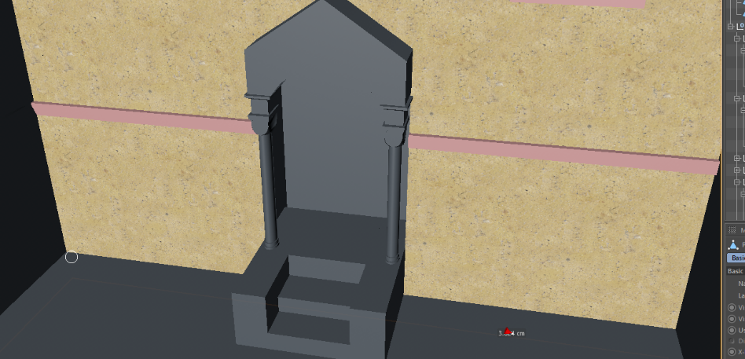
Used sources | article_01_Page182_Abb14  photo_location_11 | 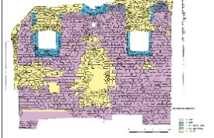  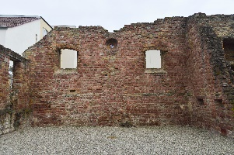
Uncertainty | Parts are still visible today, the rest can easily be deducted | Level 3/4
Argumentation | Parts of the cornice are still visible today. The rest could be reconstructed on the basis of the report drawing

Beams_a

Reconstruction | 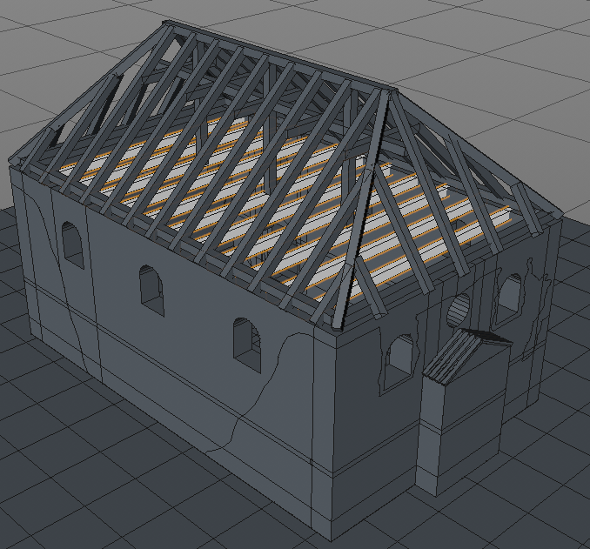
Used sources | http://www.urbs-mediaevalis.de/pages/studienportal/bauteiltypologie/bauteile-w/walmdach.php | 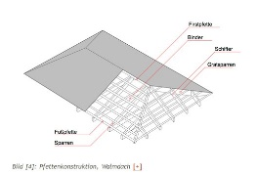
Uncertainty | Nothing is left of the roof therefore analogy has to be used | Level 1
Argumentation | There are no remains of the roof, so it was reconstructed according to the rules of a hipped roof.

Ceiling

Reconstruction | 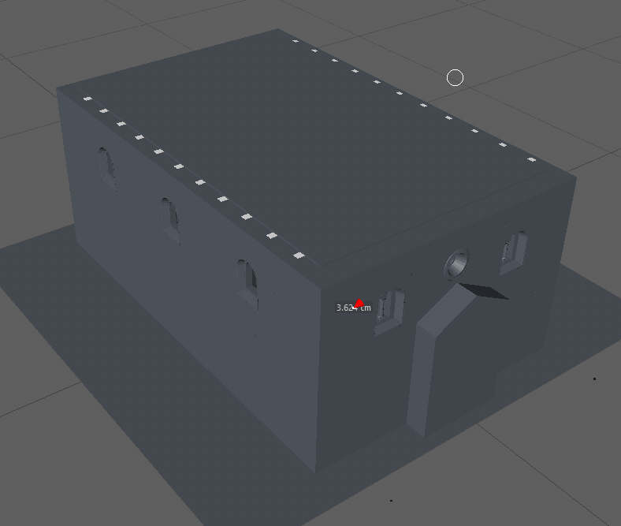
Used sources | http://www.urbs-mediaevalis.de/pages/studienportal/bauteiltypologie/bauteile-w/walmdach.php
Uncertainty | Nothing is left of the roof therefore analogy has to be used | Level 1
Argumentation | The ceiling was reconstructed to provide a ceiling to the room and create an attic

Beams_b

Reconstruction | 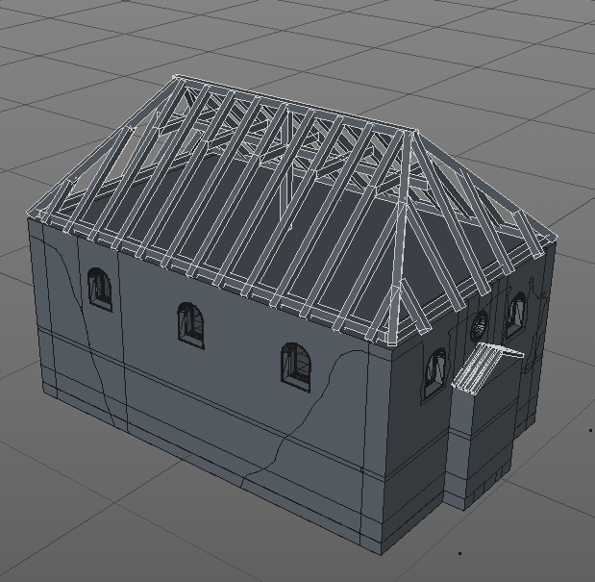
Used sources | http://www.urbs-mediaevalis.de/pages/studienportal/bauteiltypolo gie/bauteile-w/walmdach.php
Uncertainty | Nothing is left of the roof therefore analogy has to be used | Level 1
Argumentation | There are no remains of the roof, so it was reconstructed according to the rules of a hipped roof.

Beams_c

Reconstruction | 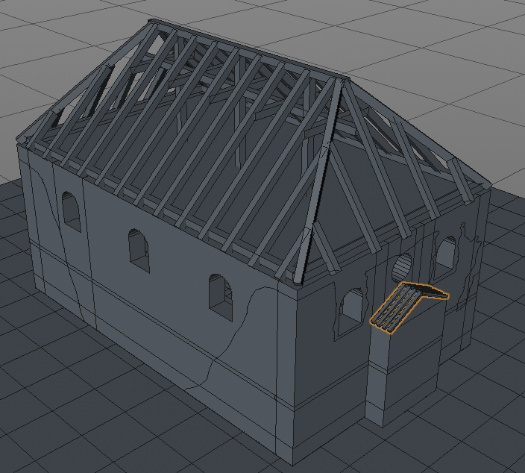
Used sources | http://www.urbs-mediaevalis.de/pages/studienportal/bauteiltypologie/bauteile-w/walmdach.php
Uncertainty | Nothing is left of the roof therefore analogy has to be used | Level 1
Argumentation | There are no remains of the roof, so it was reconstructed according to the rules of a hipped roof.

Roof_a

Reconstruction | 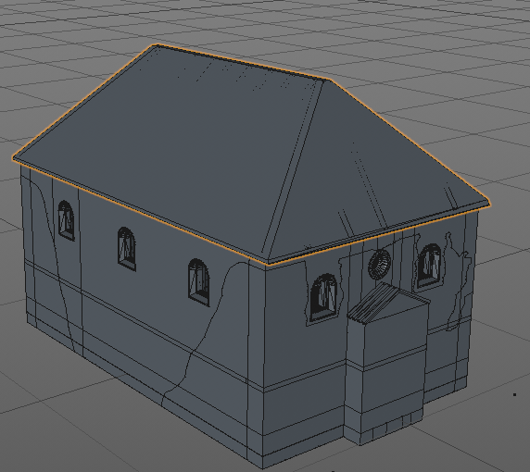
11 | http://www.urbs-mediaevalis.de/pages/studienportal/bauteiltypologie/bauteile-w/walmdach.php
Uncertainty | Nothing is left of the roof therefore analogy has to be used | Level 1
Argumentation | The roof was modelled according to the beams.

Roof_b

Reconstruction | 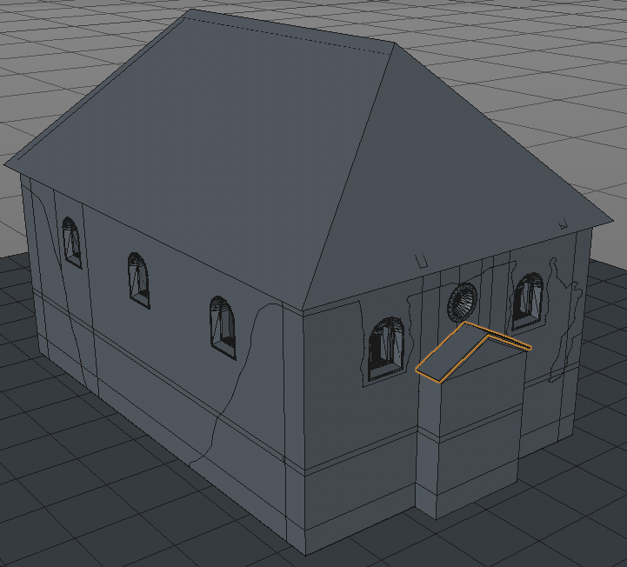
11 | http://www.urbs-mediaevalis.de/pages/studienportal/bauteiltypologie/bauteile-w/walmdach.php
Uncertainty | Nothing is left of the roof therefore analogy has to be used | Level 1
Argumentation | The roof was modelled according to the beams.

Foundation

Reconstruction | 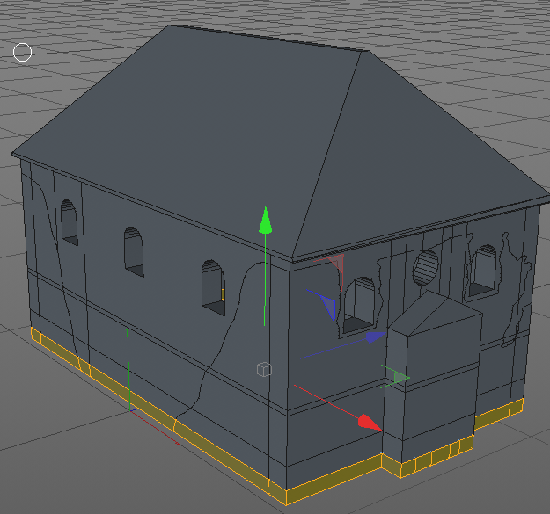
Used sources | report_drawing_03
Uncertainty | The foundation still exists and is recorded in the archaeological report | Level 4
Argumentation | The foundation was modelled with the report drawing as reference

