Workflow in Blender
Set up the reconstruction and created the semantic architectural structure, by creating new collections and adding the corresponding elements into these “folders”. | 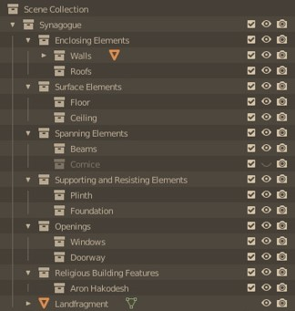
Started the basic groundwork for the reconstruction of the synagogue by adding and scaling all necessary reference images. The certainty of all elements was researched and written down, to add to the planned reconstructions. | 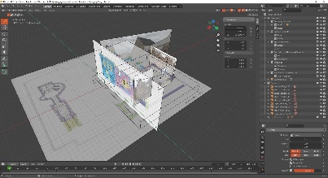
Reconstructed the still existing windows, the walls (which were separated after marking the still existing part with the knife tool) and foundation, as well as first experimentation on how to add the windows into the reconstructed walls (Booleans) and adding the correct textures. | 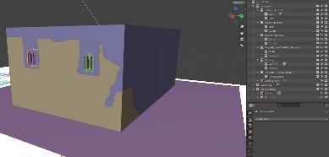
Reconstructed the rest of the windows by using text references and adding these with the correct textures into the reconstructed walls of the synagogue. | 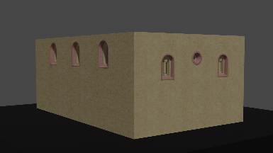
Reconstructed all the elements of the doorway of the synagogue, researched and added the plinth, and reconstructed the floor on the inside of the building. | 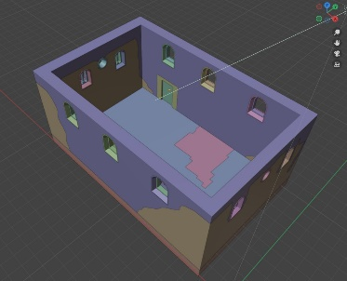
Added the Aron HaKodesh space on the outside of the eastern façade and reconstructed the elements of the Aron HaKodesh on the inside of the synagogue. | 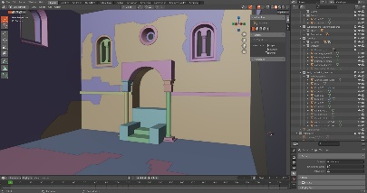
Reconstructed the cornice and all necessary beams as well as the roof of the synagogue. Textured all elements and checked for any errors or wrong names /certainty levels. | 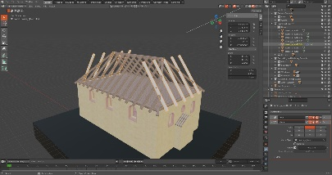
Reviewed all reconstructed elements and added the correct names and certainty levels to the object properties. Checked the rotation, scale and location of all elements and set the location of all elements to the same coordinate. | 