Workflow in Blender
Implementation of the semantic components using named groups (‘Collections’ in Blender) that structured using the suggested hierarchy. The objects are then placed inside the innermost collections.
The ground plane was created using a cube mesh, which was then enlarged to 25x25x3m by typing in those dimensions into its attributes. | 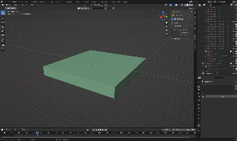
Some of the sources were added to the scene (here: floor plans) by simply importing them and scaling them to the correct size. The walls were modelled by extruding a cube mesh along the walls of the floor plan. | 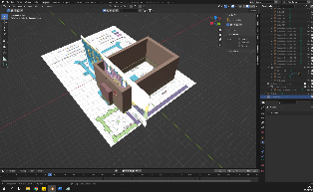
The foundation was added by copying the bottom plane of the wall mesh and then extruding t to the correct depth. The openings were cut out from the wall mesh by using a Boolean modifier, which made them non-destructive and easily modifiable at this stage. | 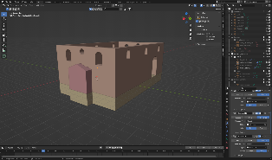
The largest roof was modelled using a cube mesh and merging its top edges to create a triangular prism.  The smaller roof was created using a cube mesh for one side of the roof and then using a mirror modifier to mirror it onto the other side. | 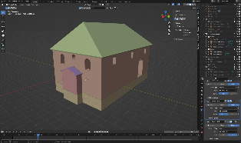
The windows were created by tracing their outline using vertices from one of the provided sources. A cylinder mesh was later added to the mesh to create the column in the major windows. | 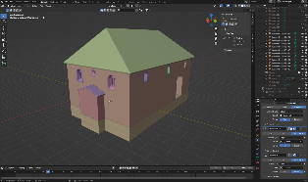
The doorway was created the same way as the windows – by tracing them from the sources. The columns, their bases and capitals were added using the Archimesh-Addon, which is already included in Blender. It les you import a set of architectural elements and then lets you change them by changing their attributes in a drop-down menu. | 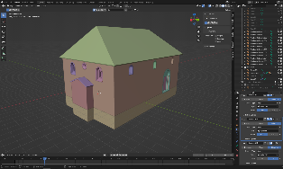
The beams were added by using a cube mesh, which was modelled into a single beam and then copying it using the array modifier. This lets you specify how often you want an element repeated and what the distance between them should be. | 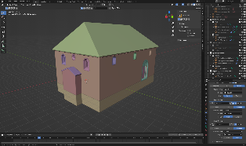
Parts of the Aaron Hakodesh was also modelled using the Archimesh-Addon (Columns, Arch, Capitals, Bases). The gable was created using the Arch-mesh from the addon and then extruding and moving some vertices. The stairs were made using a simple cube mesh. | 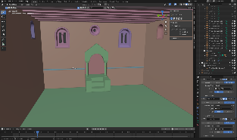
The wall was separated by using a boolean modifier. The hole was then filled by adding a new mesh that fit the missing space perfectly. | 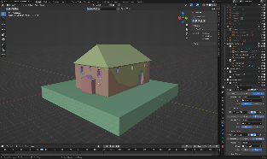
The texture tiles were added to the unwrapped UVs of the objects. They were then scaled and rotated. | 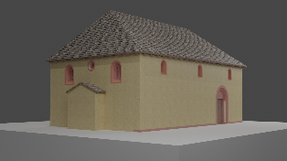
The uncertainty scale was implemented by including the level in the object name. The name also includes the ID from the semantic elements described in the handout.

