Workflow in “Rhinoceros”
Creation of layers for uncertainty visualisation: “04-still existing” (blue); “03-deduction” (green); “02-analogy” (yellow); “01-hypothesis” (red); “00-not considered (black) | 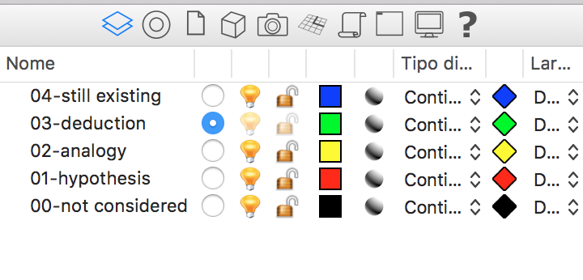
Creation of object materials and related visualisation colours according to the handout. The materials have been called “plaster” (texture_01); “frames” (texture_02); “floor” (texture_03); “door ceiling beams” (texture_04); “roof” (texture_05). | 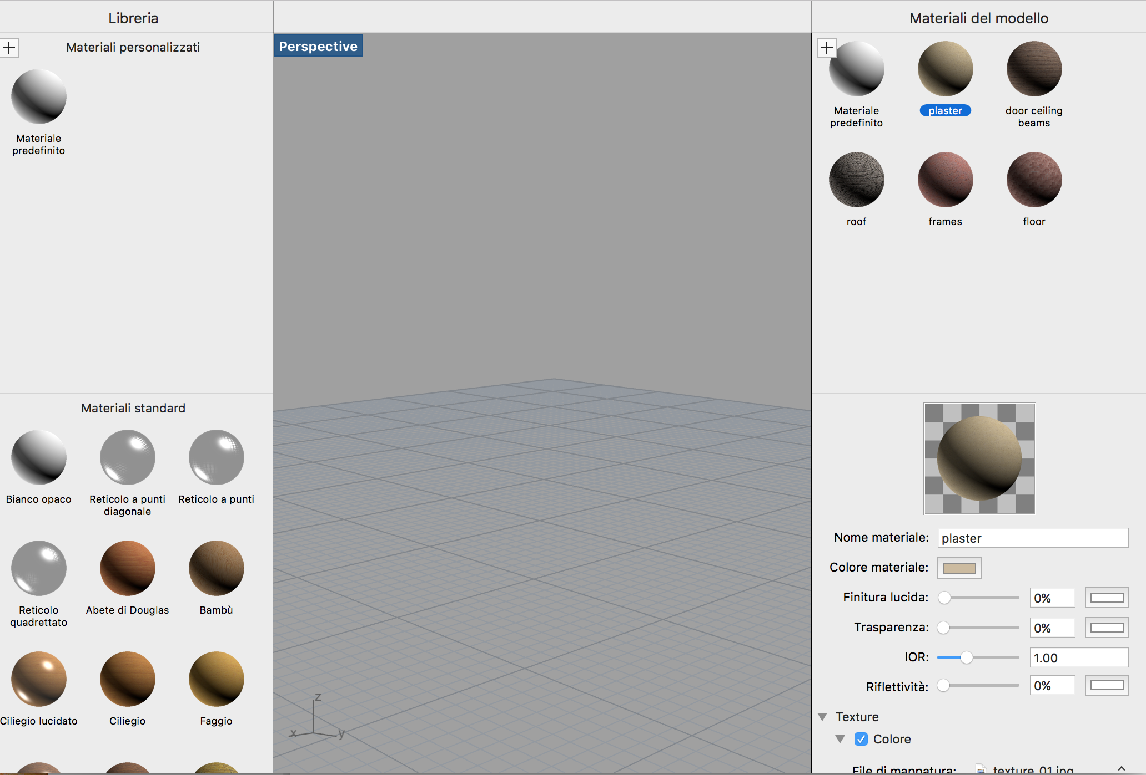
Basement  Obtained by extrusion (3 m) of a 25x25 m square  Object name: “basement”  Layer: “00-not considered”; colour: “by layer” (black); material: not defined. | 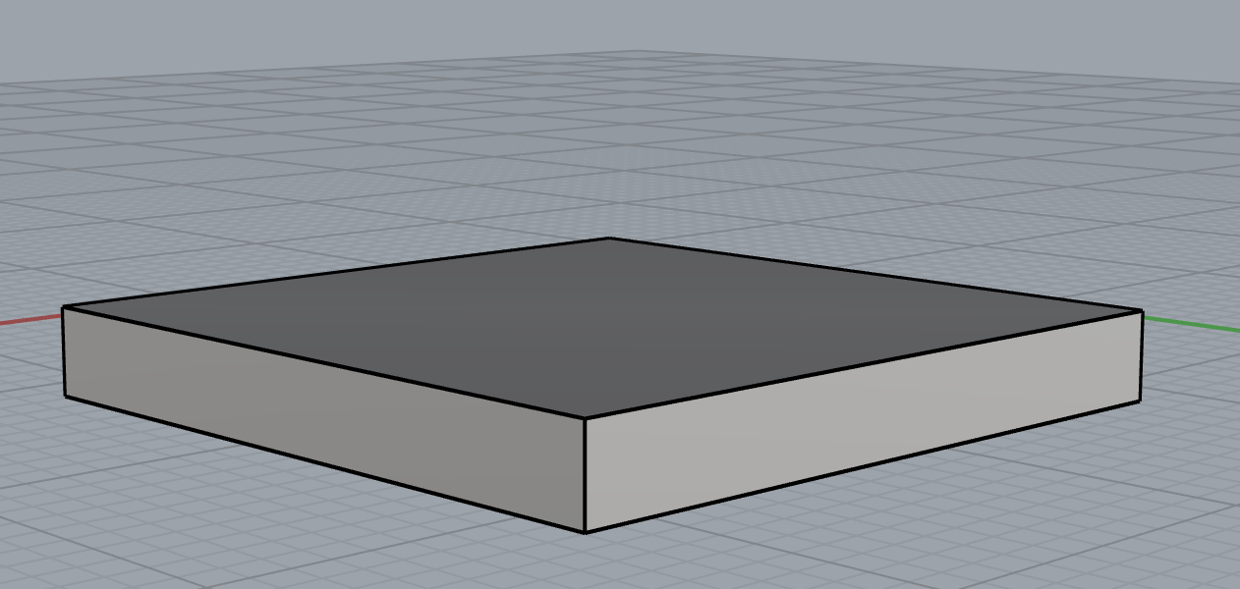
Foundations  Obtained by extrusion of the related surface as in “report_03.jpg”  Object name: “foundations”  Layer: “04-still existing”; colour and material according to texture_01 | 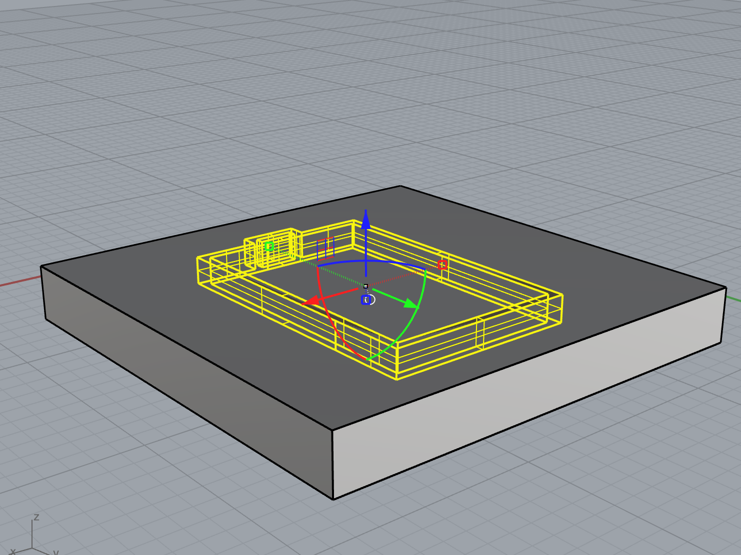
Perimeter walls  Obtained by extrusion of the related surface  Object name: “wall_2”  Layer: “03-deduction”; colour and material according to texture_01 | 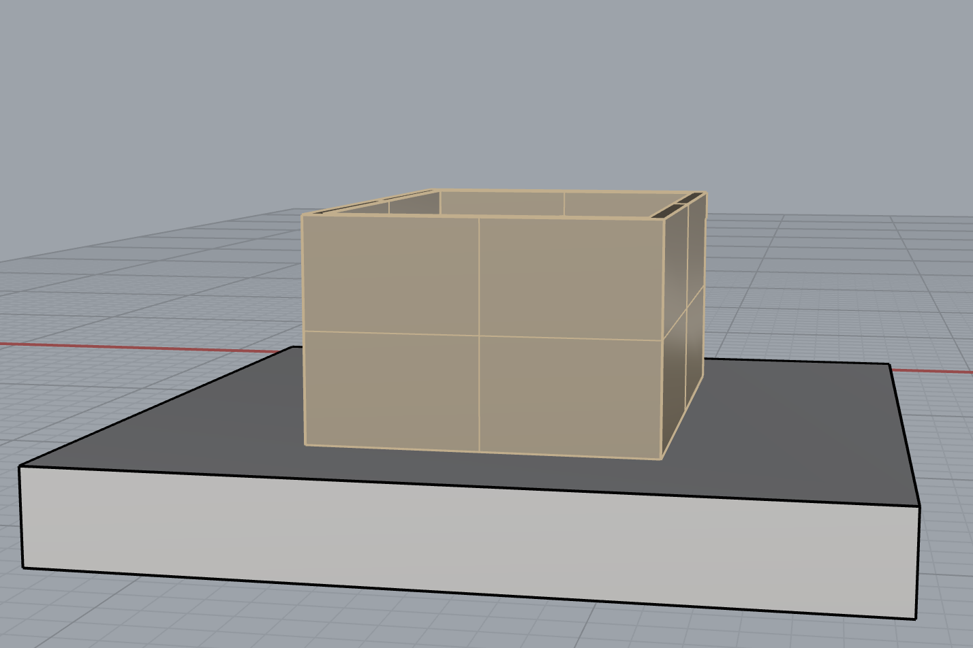
Subdivision of the eastern façade  Obtained by cutting “wall_2” according to the information in “report_05.jpg”  Object name: “wall_1”  Layer: “04-still existing”; colour and material according to texture_01 | 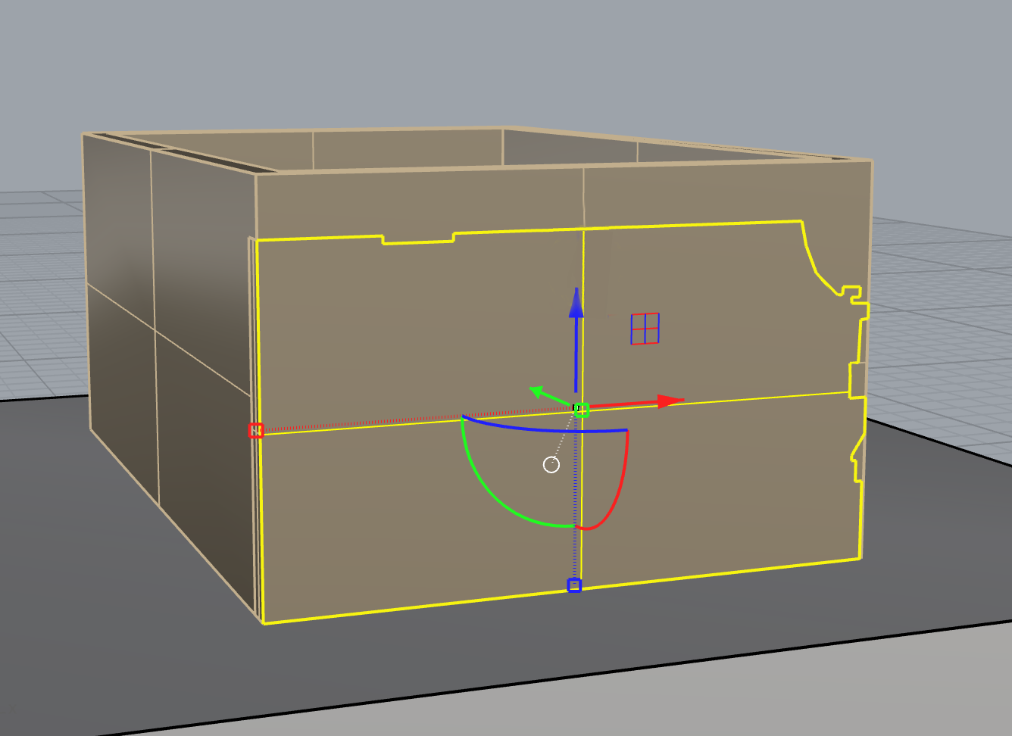
Holes for windows  Obtained by Boolean difference | 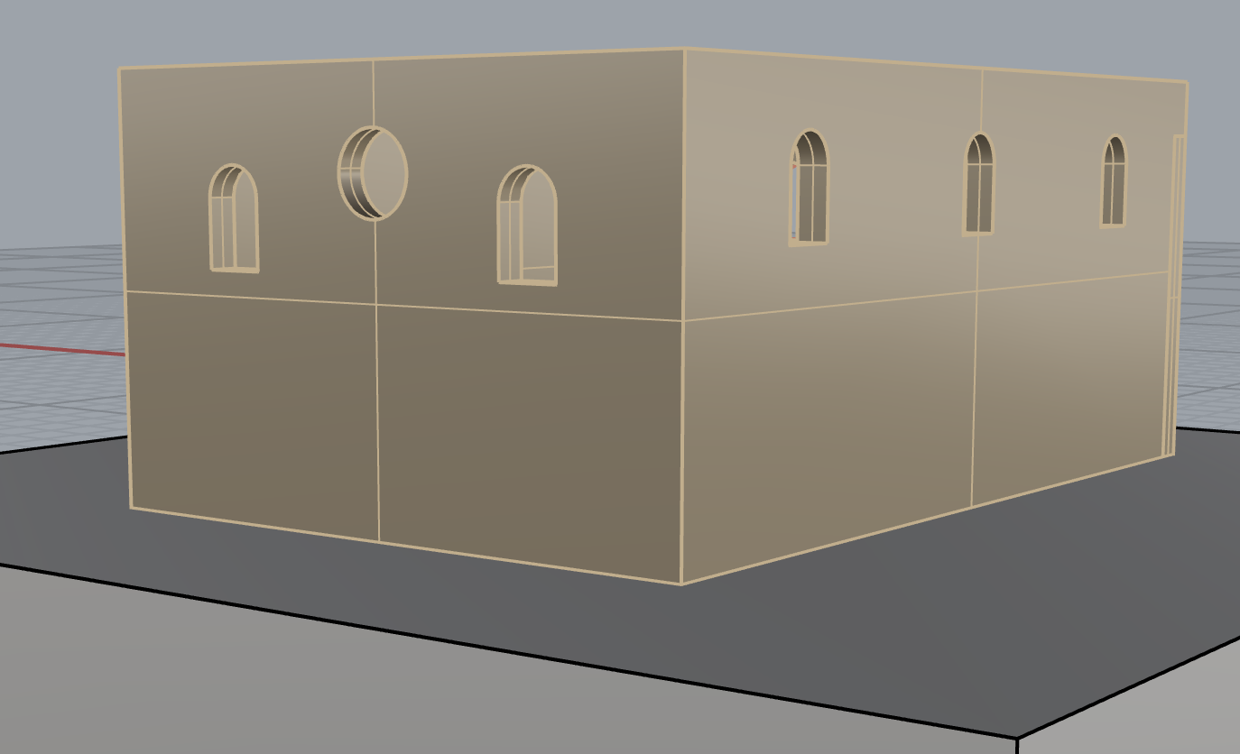
Hole for portal  Obtained by Boolean difference | 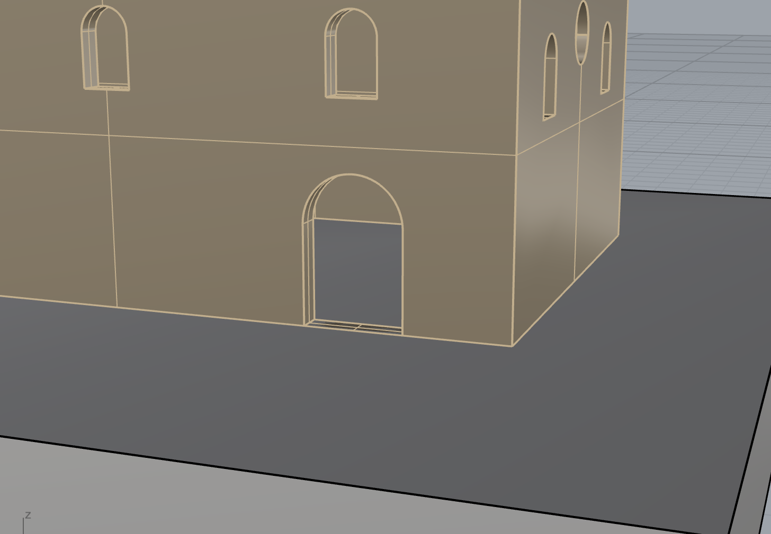
Floor  Obtained by extrusion of the area inside the perimeter walls.  Object name: “floor”  Layer: “01-hypothesis”  Colour and material according to texture_03 | 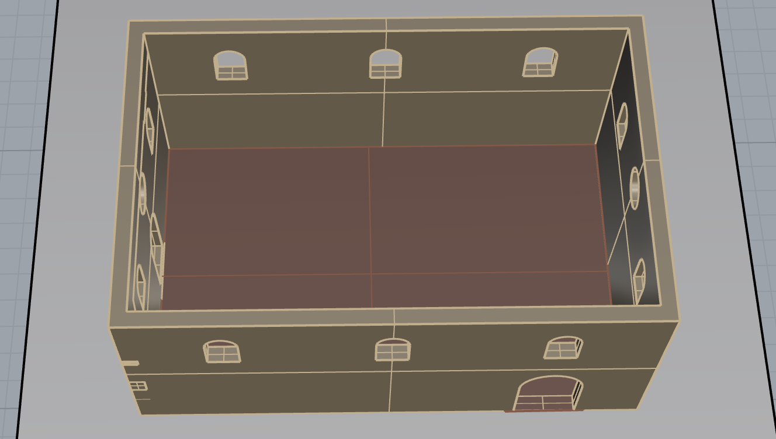
“Bifora” windows  Obtained by extrusion and by rotation (columns)  Frames obtained by extrusion and loft  Object name: “window_1”  Layer: “04-still existing” for those in the western façade; “03-deduction” for the other ones; colour and material according to texture_01 for the internal part and texture_02 for the frames | 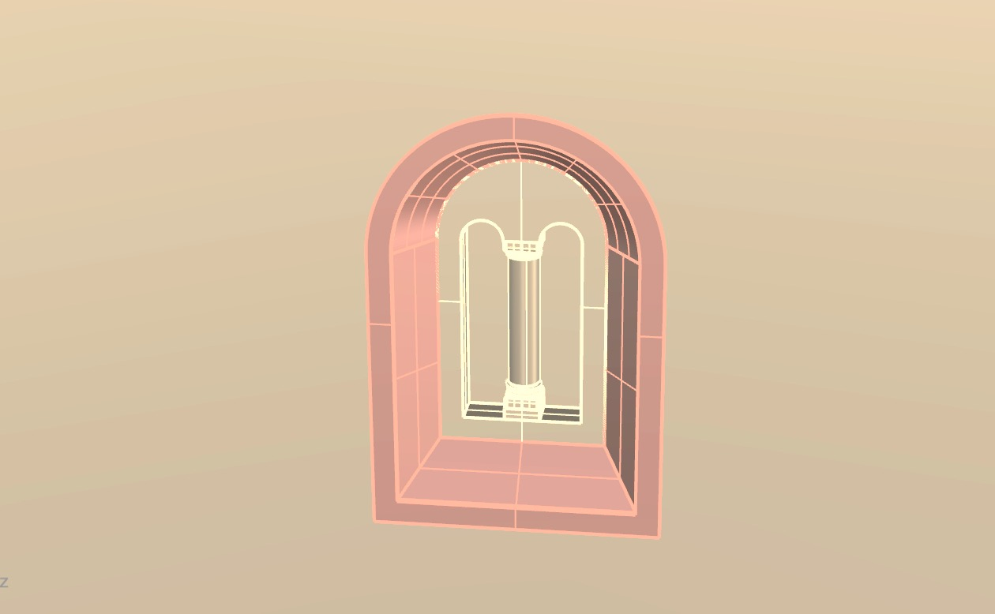
Circular windows  Frame obtained by extrusion and loft around the circular hole  Object name: “window_2”  Layer: “03-deduction”; colour and material according to texture_02 | 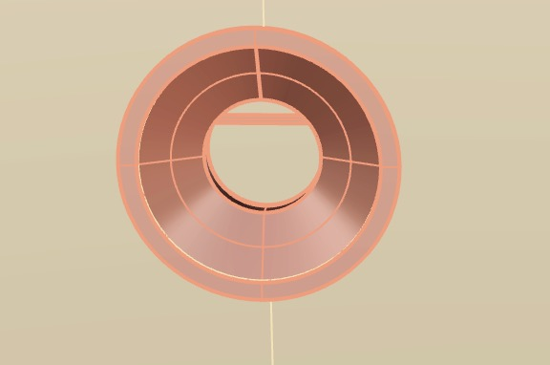
Arch windows  Obtained by extrusion  Frames obtained by extrusion and loft  Object name: “window_3”  Layer: “01-hpothesis”, colour and material according to texture_01 for the internal part and texture_02 for the frames | 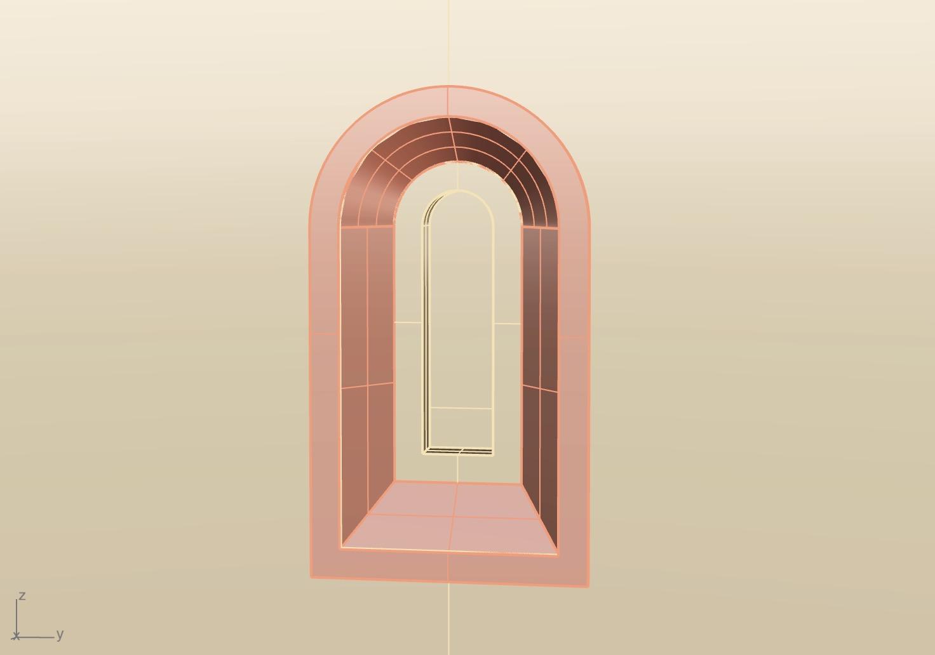
Portal  Some details are still needed. Mainly obtained by extrusion.  Object name: “portal”.  Layer: “02-analogy”  Colour and material according to texture_02 for the frames, texture_01 for columns and semi-circular wall above the door, texture_04 for the door | 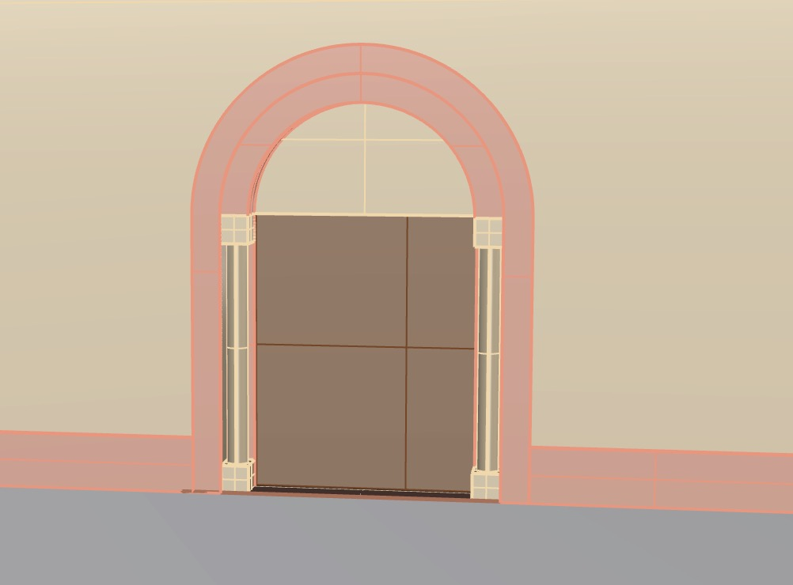
Beams
Obtained by drawing the rectangular section, extruding it for all the length of the beam that was then copied many times (some are horizontal, for the others the angle is 35°; the length varies according to the construction scheme)
Object name: “beams”
Layer: “01-hypothesis”; colour and material according to texture_04
Roof  Four surfaces with a 35° angle were created above the beams, then they were extruded  Object name: “roof”  Layer: “01-hypothesis”; colour and material according to texture_05 | 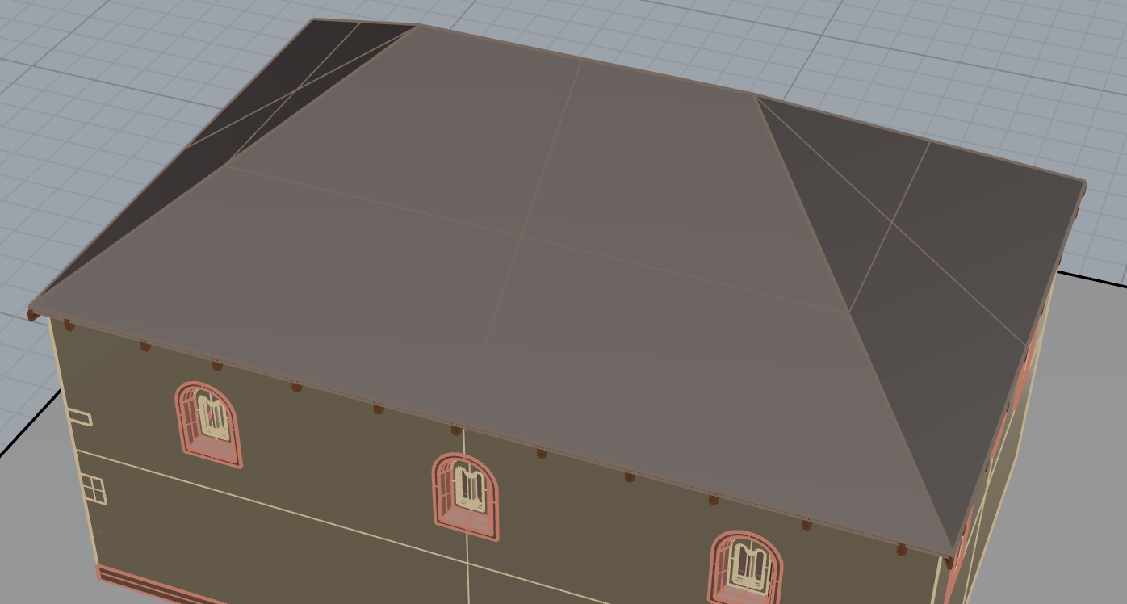
Aron Hakodesh – exterior  The walls were extruded according to the foundation. The roof follows the traces of the arch on the eastern façade.  Object name: “aron hakodesh_exterior”  Layer: “02-analogy”; colour and material according to texture_01 for the wall, texture_04 for the beams and texture_05 for the roof | 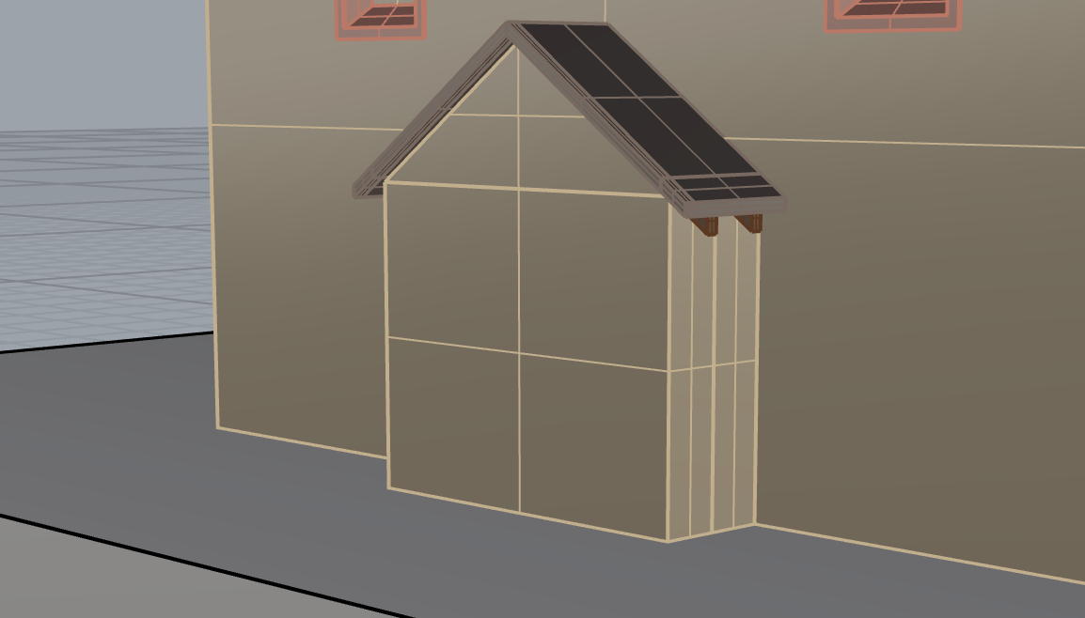
Aron Hakodesh  Basement, stairs and upper part modelled by extrusion, columns by rotation.  Layer: “02-analogy”, colour and material according to texture_01 apart from the stairs, for which texture_03 is used | 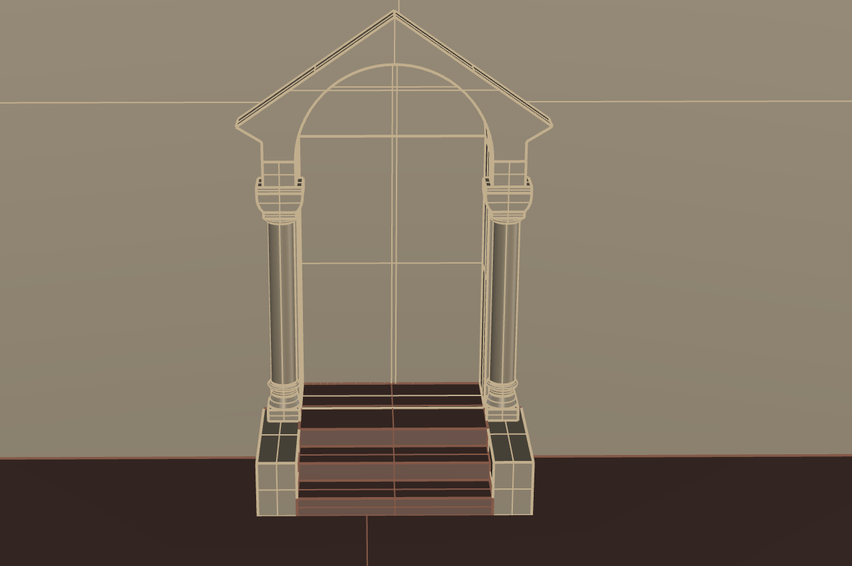
Plinth  Obtained by extrusion of a part of the wall.  Layer: “03-deduction”  Colour and material according to texture_02 | 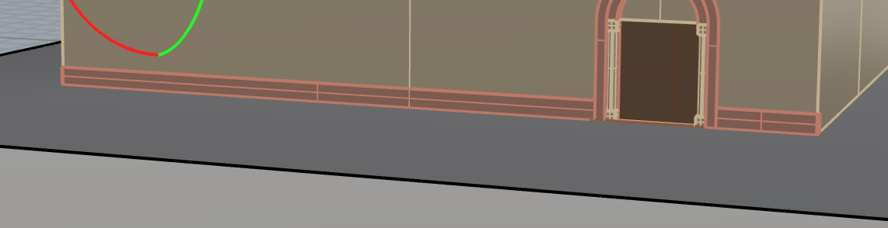
Cornice
Obtained by extrusion of a part of the wall.
Layer: “03-deduction”
Colour and material according to texture_02

