Wall type 1

Reconstructed object | 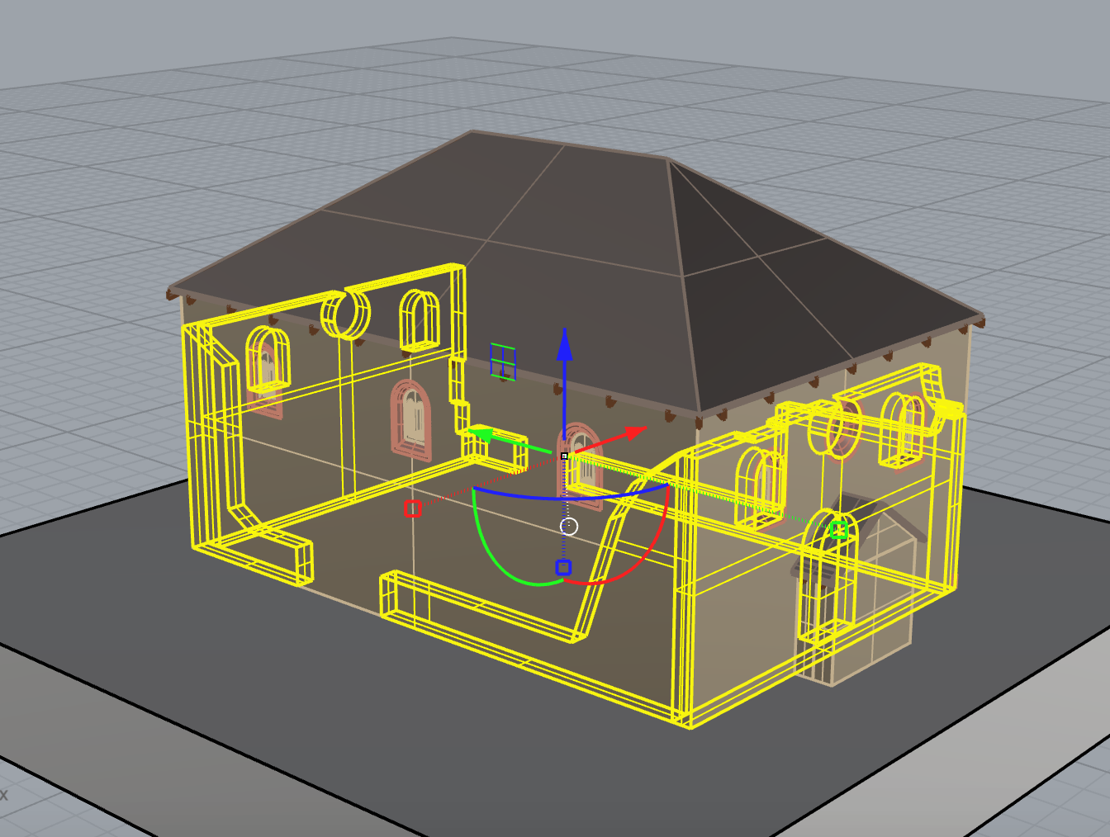
Used sources | report_05.jpg | 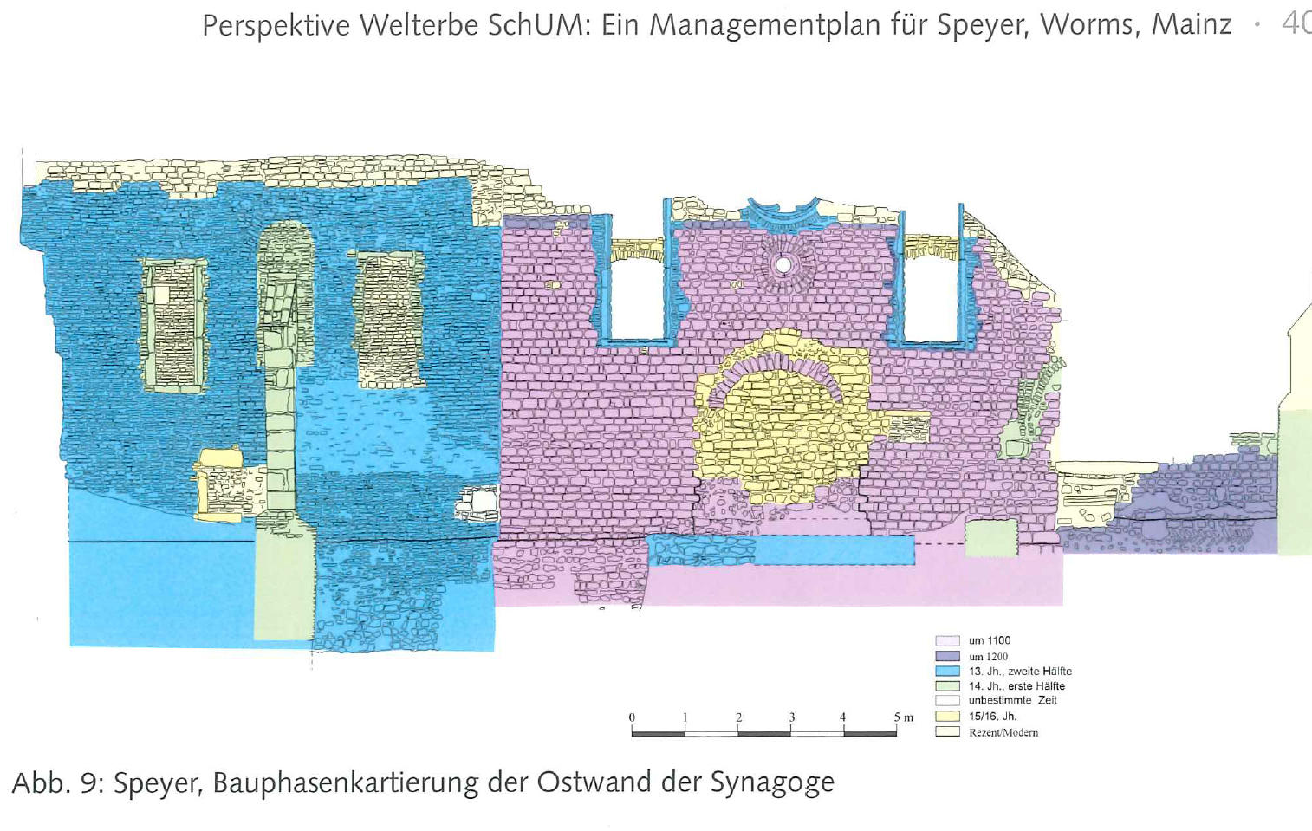
 | photo_location_01.jpg | 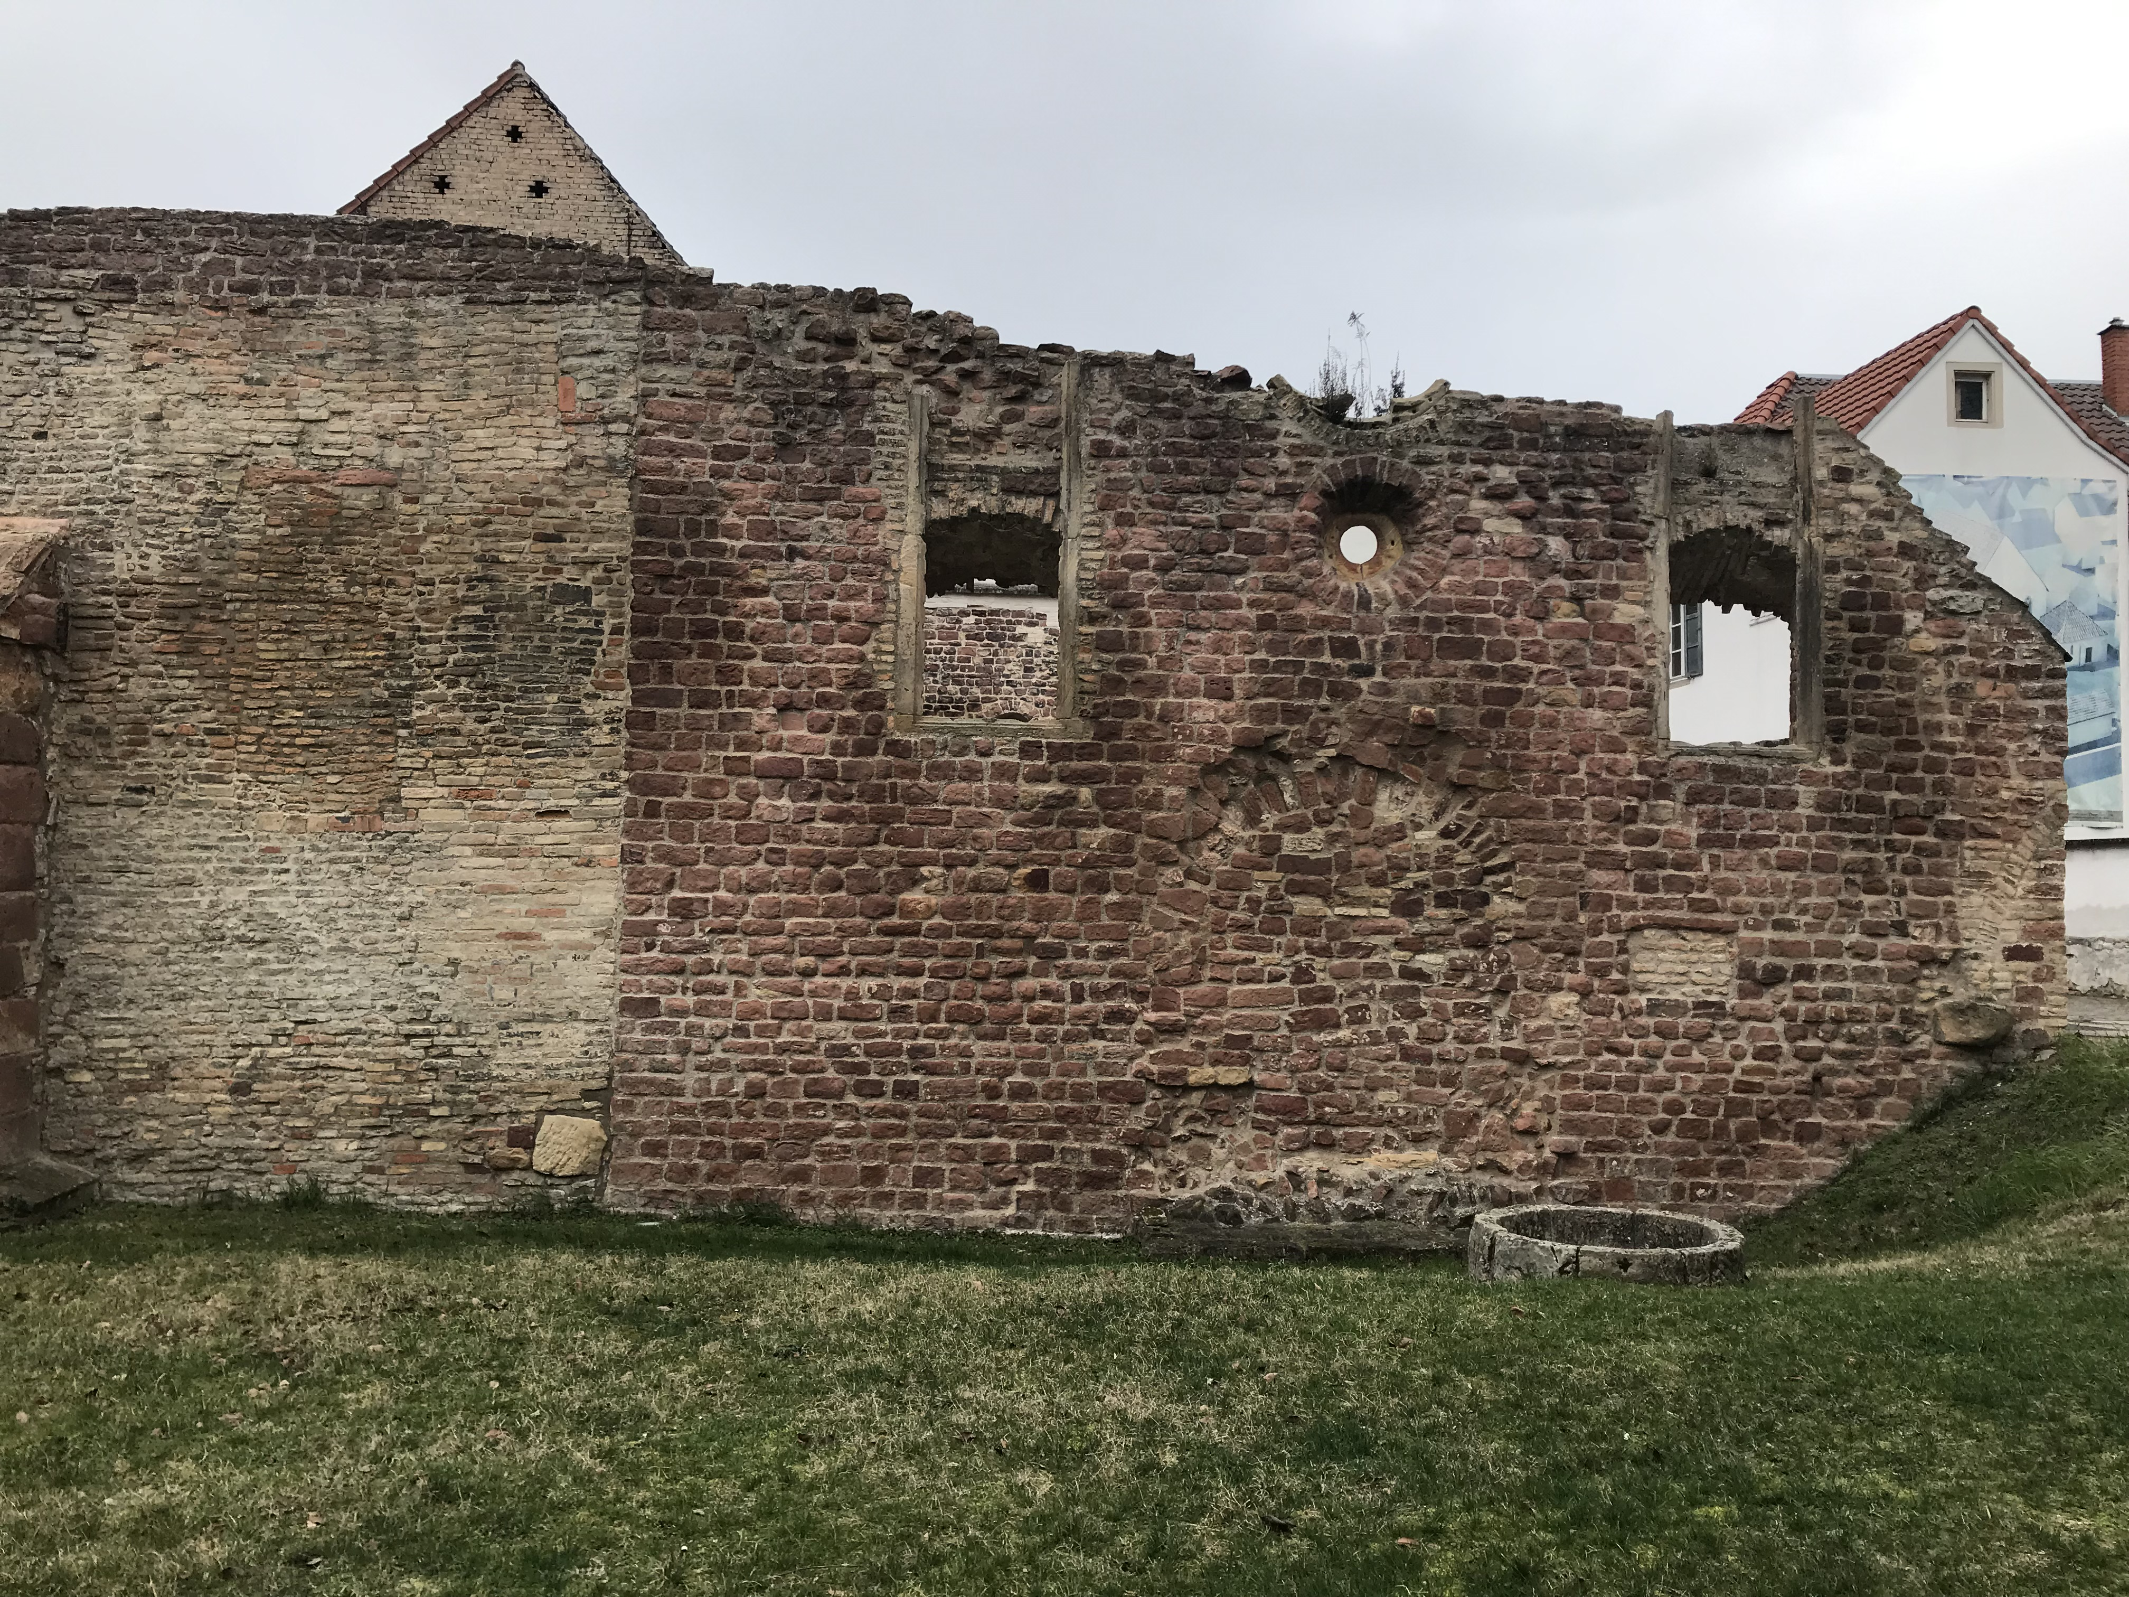
Argumentation and evaluation of the uncertainty | This is the part of the wall that we can still see | 04-still existing

Wall type 2

Reconstruction | 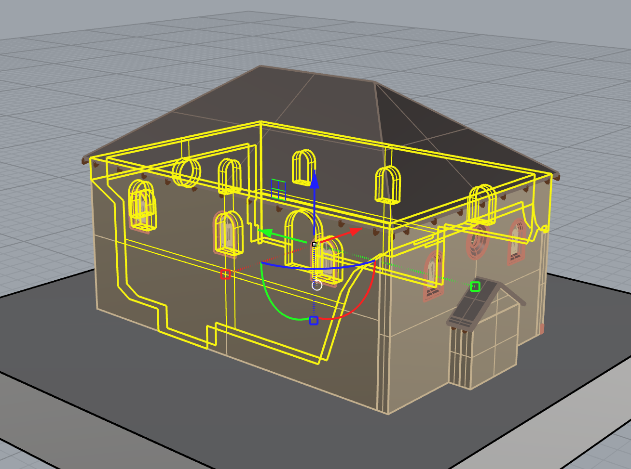
Used sources | report_05.jpg
 | photo_location_01.jpg
Uncertainty | This part of the wall was reconstructed by deduction, assuming that it was similar to the still existing part | 03-deduction

Window type 1

Reconstruction | 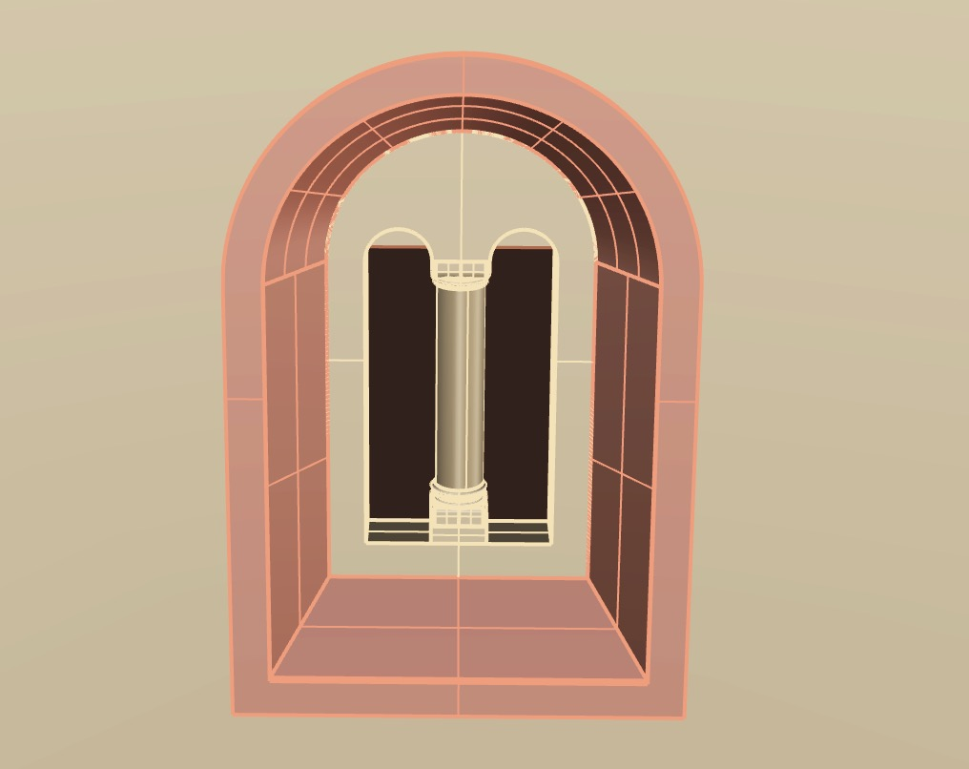
Used sources | photo_location_04.jpg | 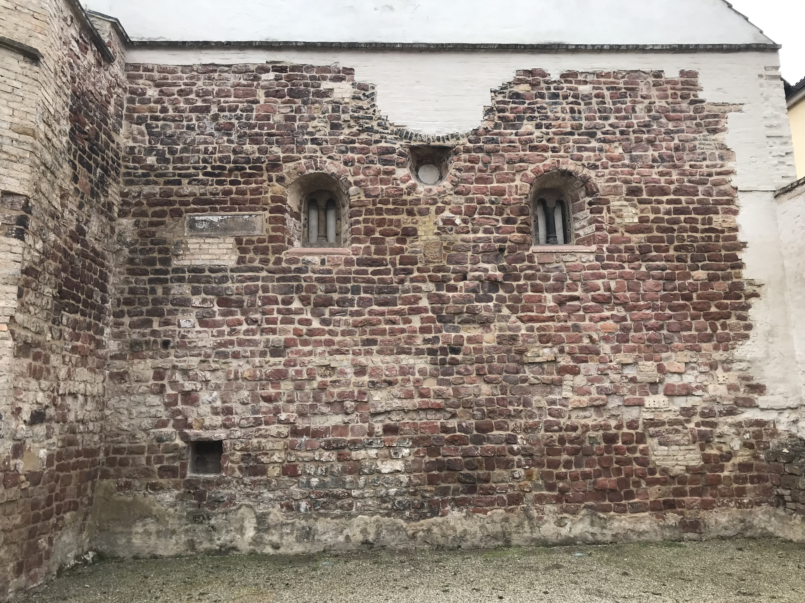
 | photo_museum_02.jpg | 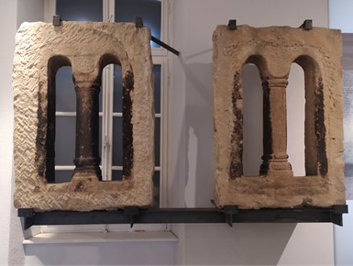
Uncertainty | The windows on the western façade are copies of the original ones preserved in the Judenhof museum, thus in that case the uncertainty level is “04-still existing”. It is assumed that the other windows were similar and can be reconstructed by deduction. | 04-still existing  for those on the western façade; 03-deduction for the other ones

Window type 2

Reconstruction | 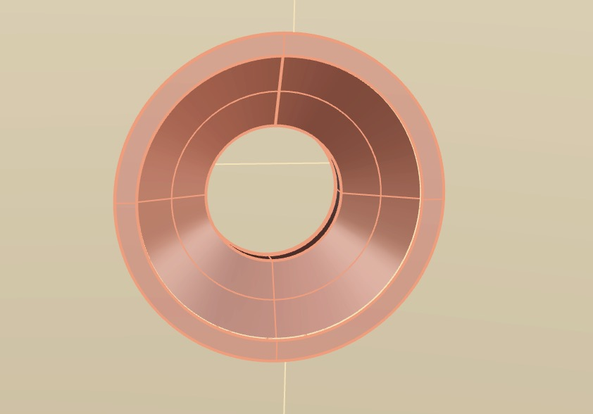
Used sources | photo_location_01.jpg
 | photo_location_04.jpg
Uncertainty | We can see the complete circular hole in the still existing part of the wall | 04-still existing

Window type 3

Reconstruction | 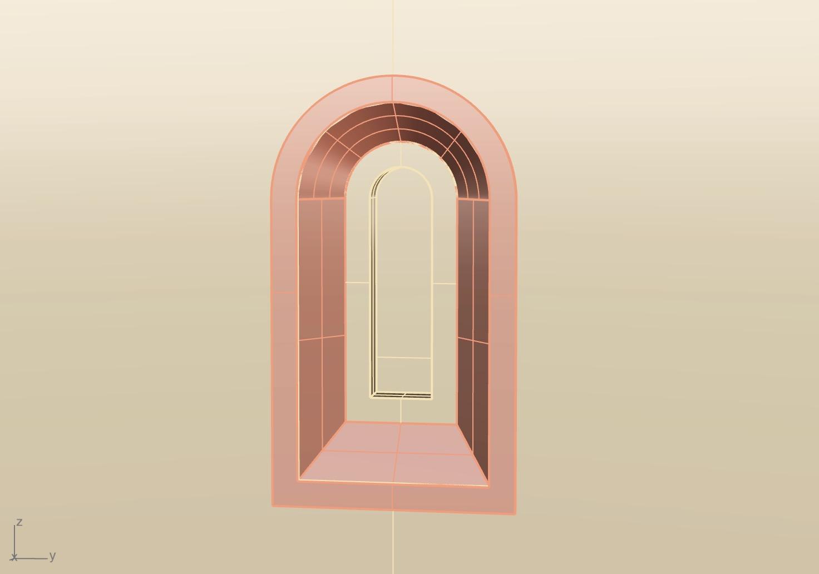
Used sources | reconstruction_01_rendering_02.jpg | 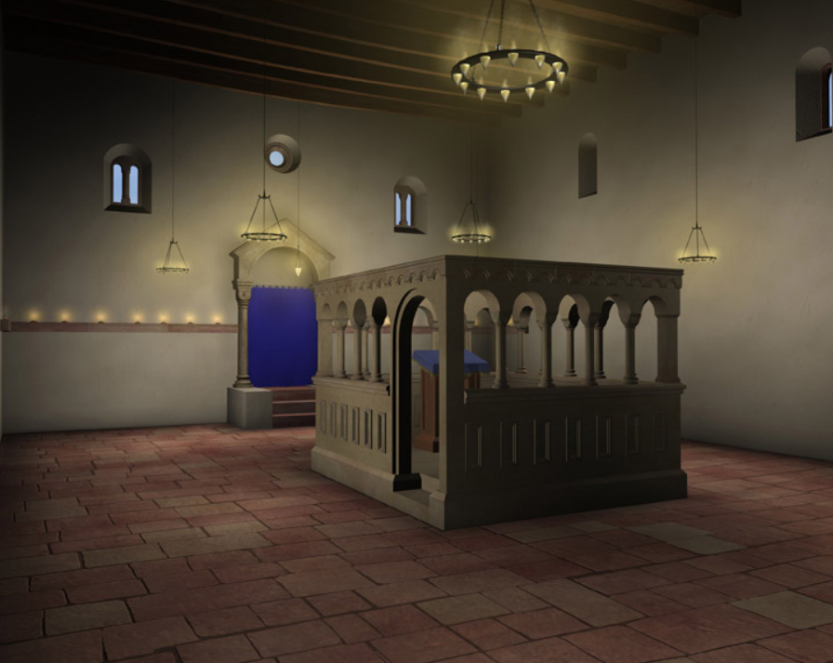
 | reconstruction_01_rendering_05.jpg
Uncertainty | We know nothing about the windows on the northern and southern façade, but there must be some source of natural light, maybe smaller than on the other walls. | 01-hypothesis

Portal

Reconstruction | 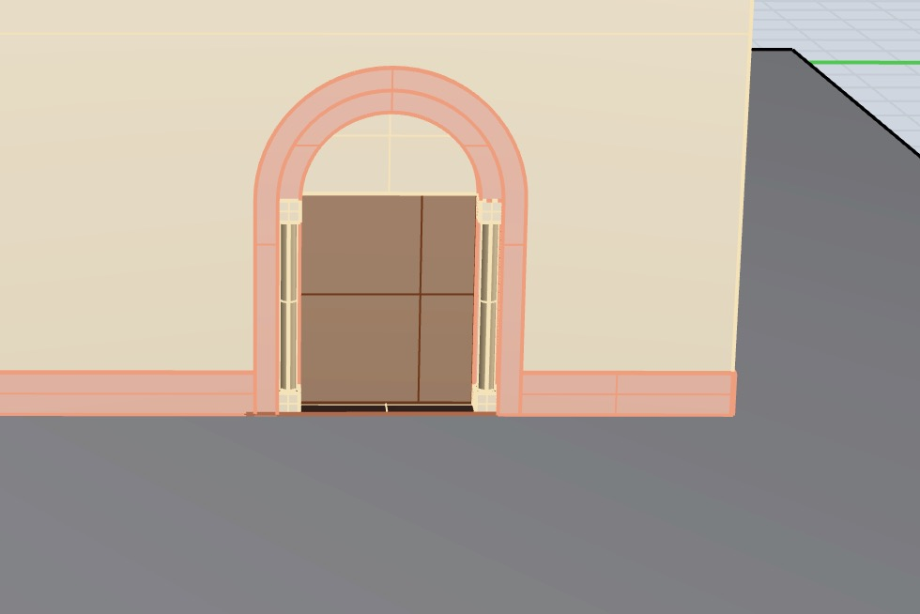
Used sources | analogy_02_01.jpg | 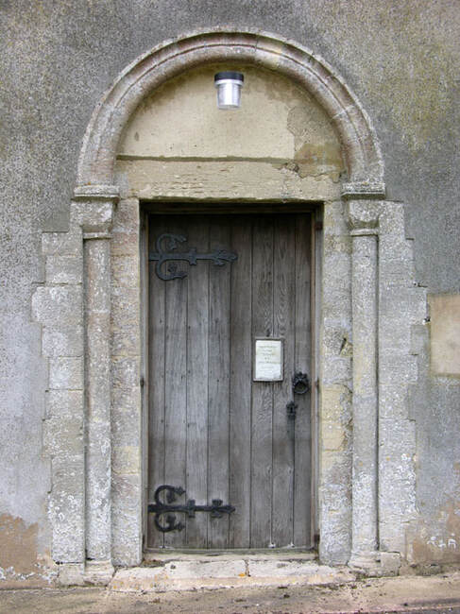
 | analogy_03.png | 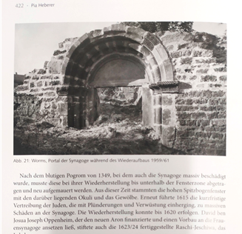
Uncertainty | We do not have traces of the portal of the Speyer synagogue, but we can reconstruct it by analogy e.g. with the portal of the medieval synagogue in Worms | 03-analogy

Beams

Reconstruction | 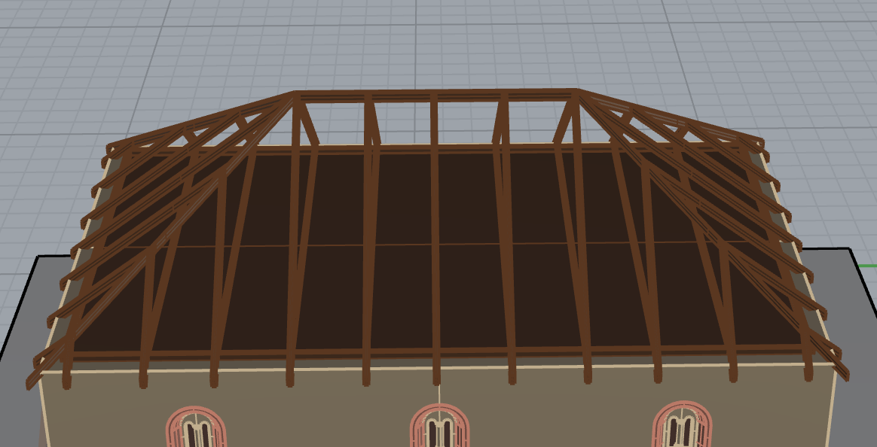
Used sources | https://s3.amazonaws.com/finehomebuilding.s3.tauntoncloud.com/app/uploads/1982/09/29111349/roof-framing-terms.jpg (accessed April 4th, 2022) | 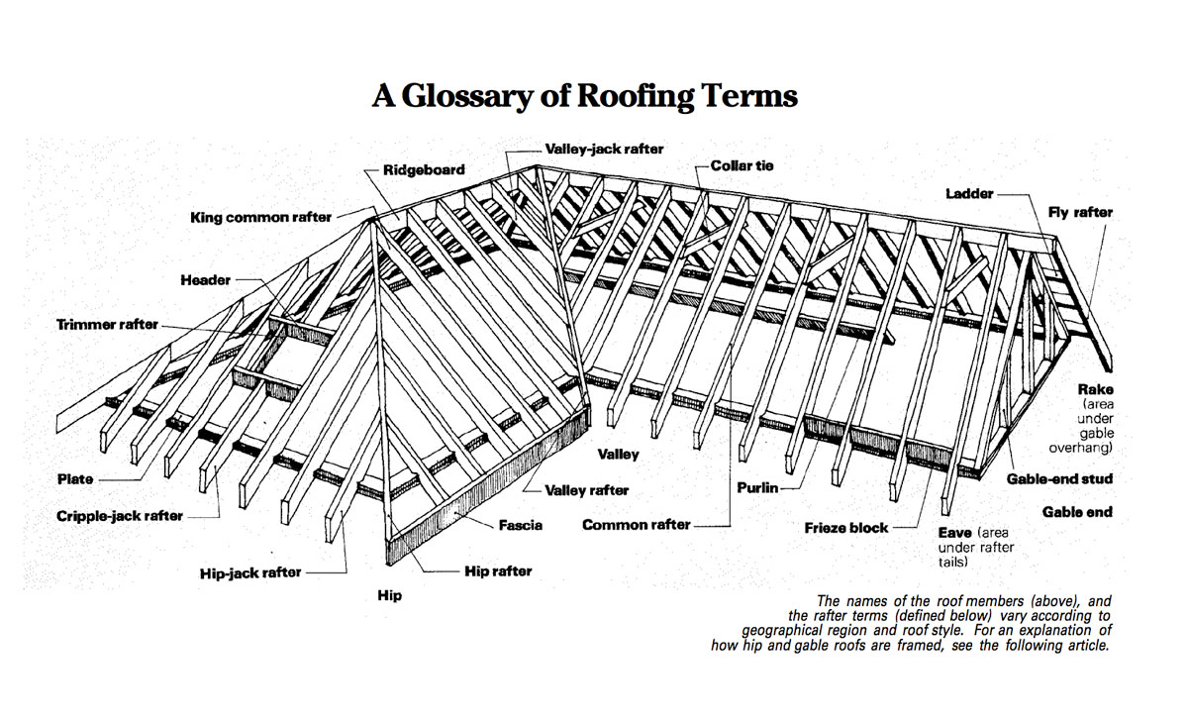
 | reconstruction_01_rendering_03.jpg | 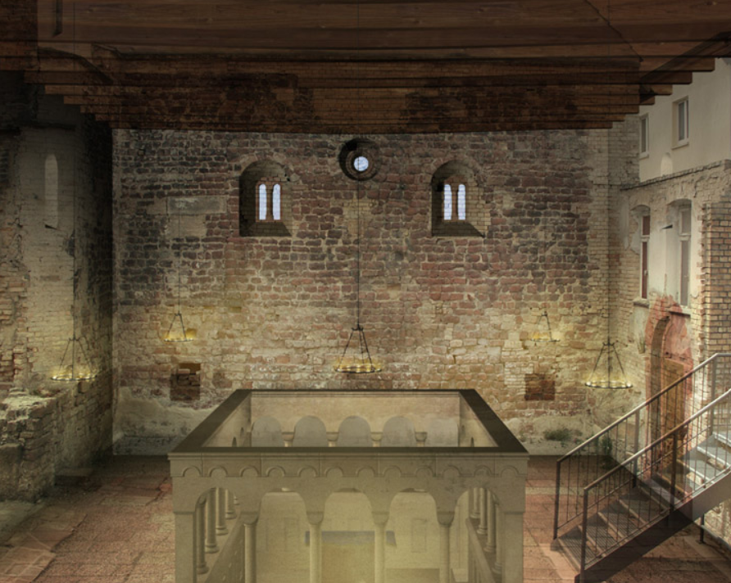
Uncertainty | We know nothing about the structure of the roof | 01-hypothesis

Ceiling

Reconstruction | 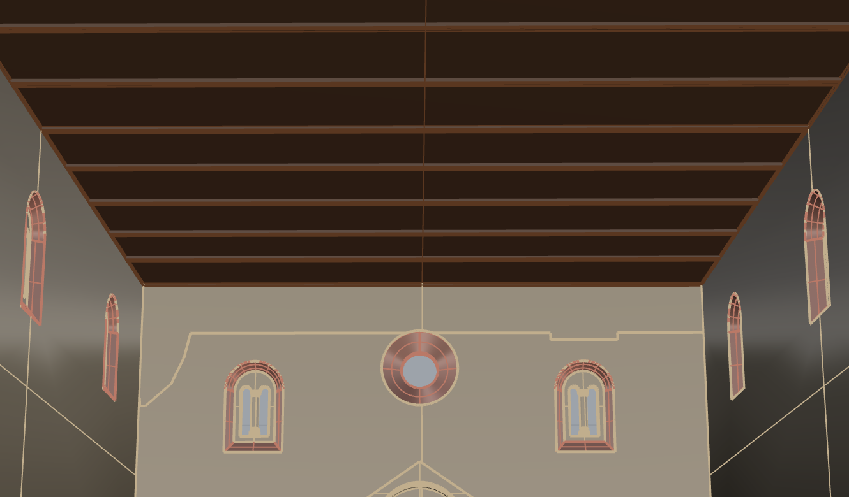
Used sources | reconstruction_01_rendering_02.png
Uncertainty | We know nothing about the structure of the roof | 01-hypothesis

Roof type 1

Reconstruction | 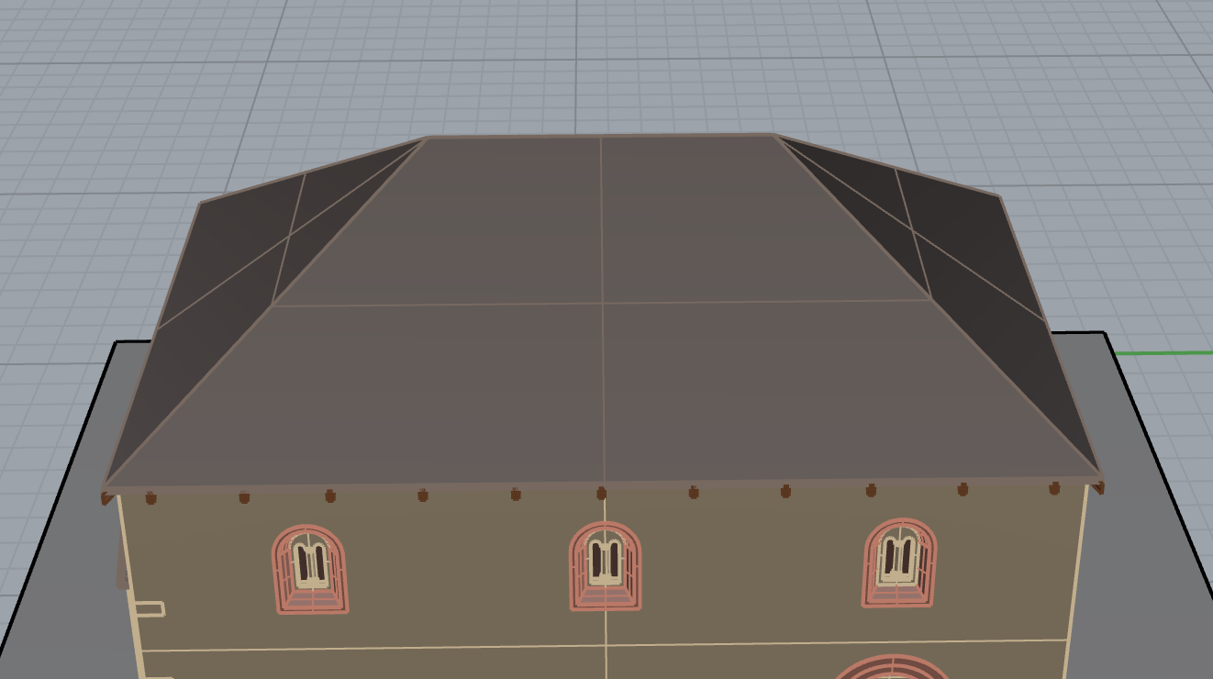
Used sources | drawing_01.jpg
 | drawing_04.jpg | 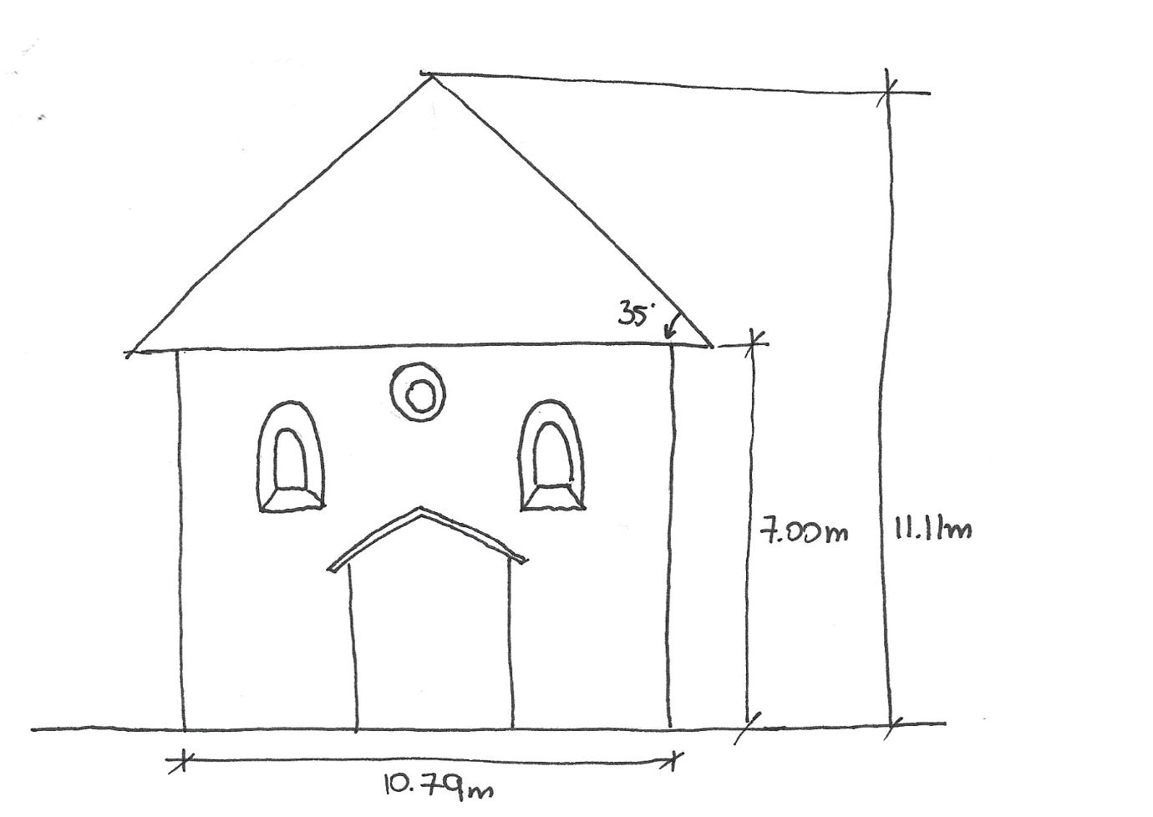
Uncertainty | We know nothing about the structure of the roof | 01-hypothesis

Roof type 2

Reconstruction | 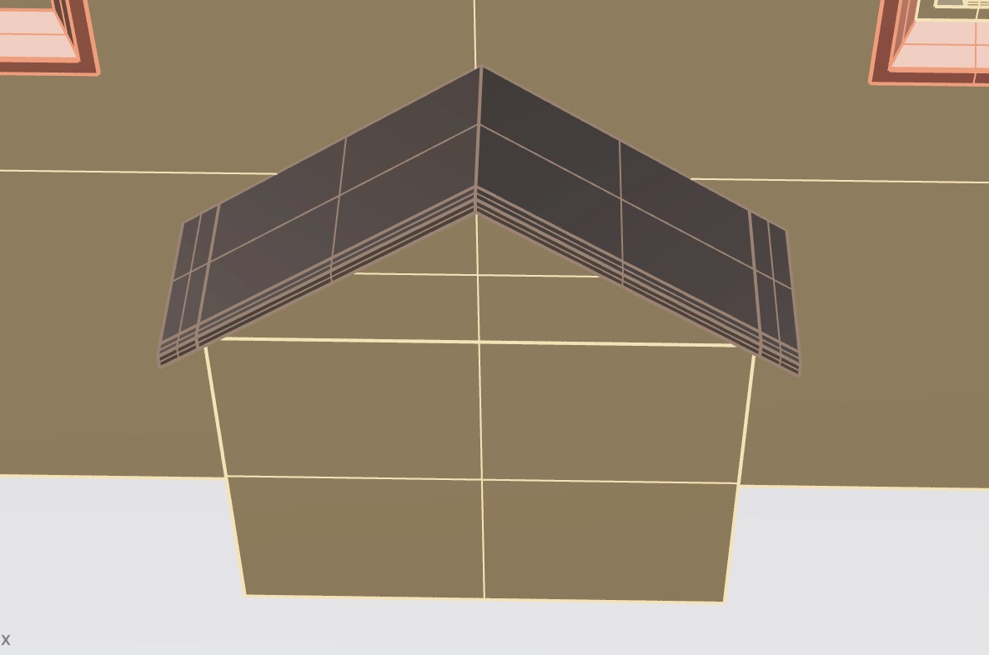
Used sources | reconstruction_01_rendering_05.jpg
Uncertainty | We know nothing about the structure of the roof. The simplest thing to assume is that the slope of the roof is the same as the upper part of the Aron Hakodesh (this can be seen in the interior). The material is assumed to be the same as the main roof. | 01-hypothesis

Aron Hakodesh

Reconstruction | 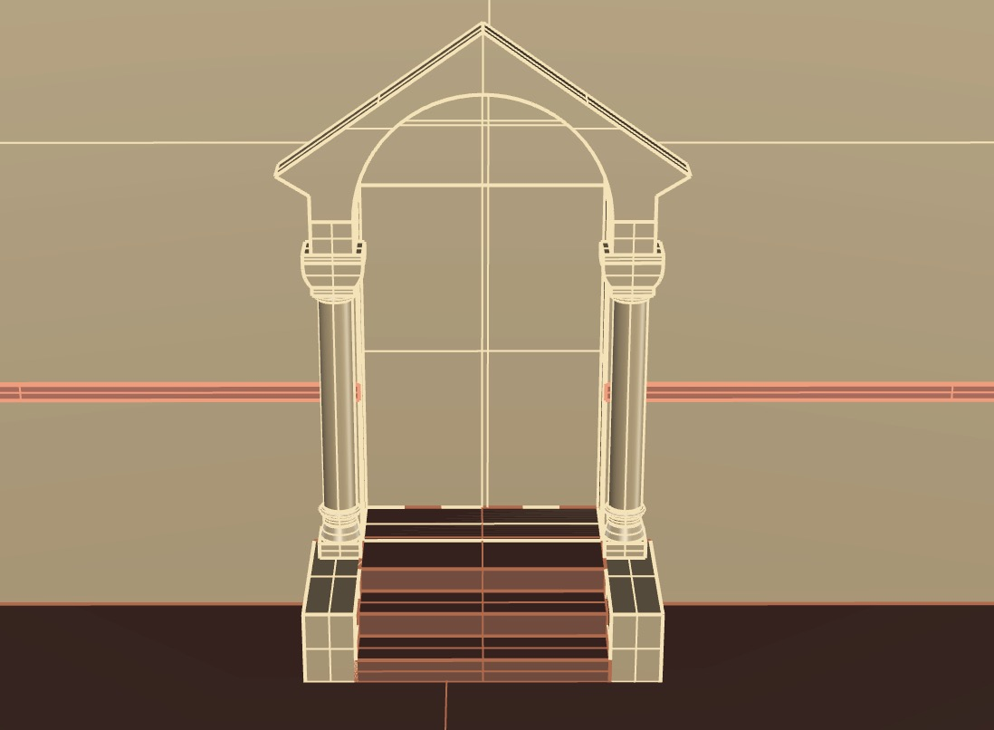
Used sources | reconstruction_01_rendering_02.png
 | Personal archive of Irene Cazzaro, who can make it accessible if required
Uncertainty | It was modelled based on similar examples of the same historical period. | 03-analogy

Cornice

Reconstruction | 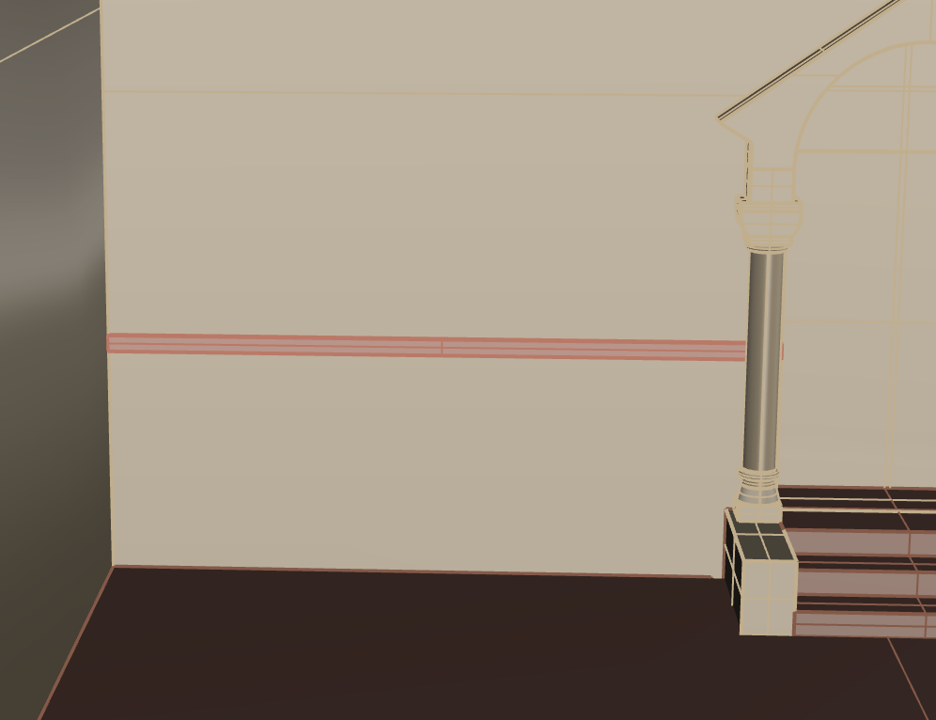
Used sources | Personal archive of Irene Cazzaro, who can make it accessible if required | 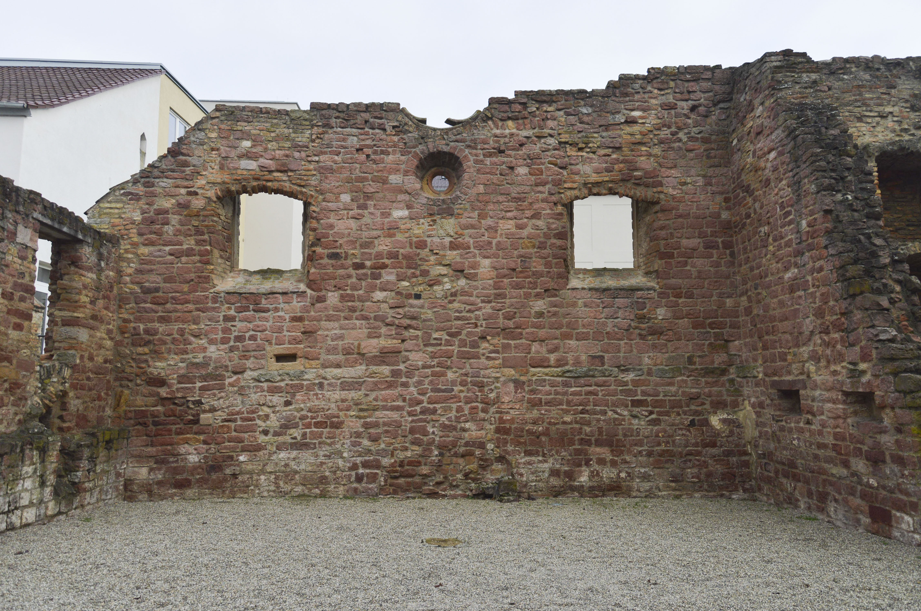
Uncertainty | There are clear traces of it in the internal part of the wall | 04-still existing

Plinth

Reconstruction
Used sources | reconstruction_01_rendering_01.jpg | 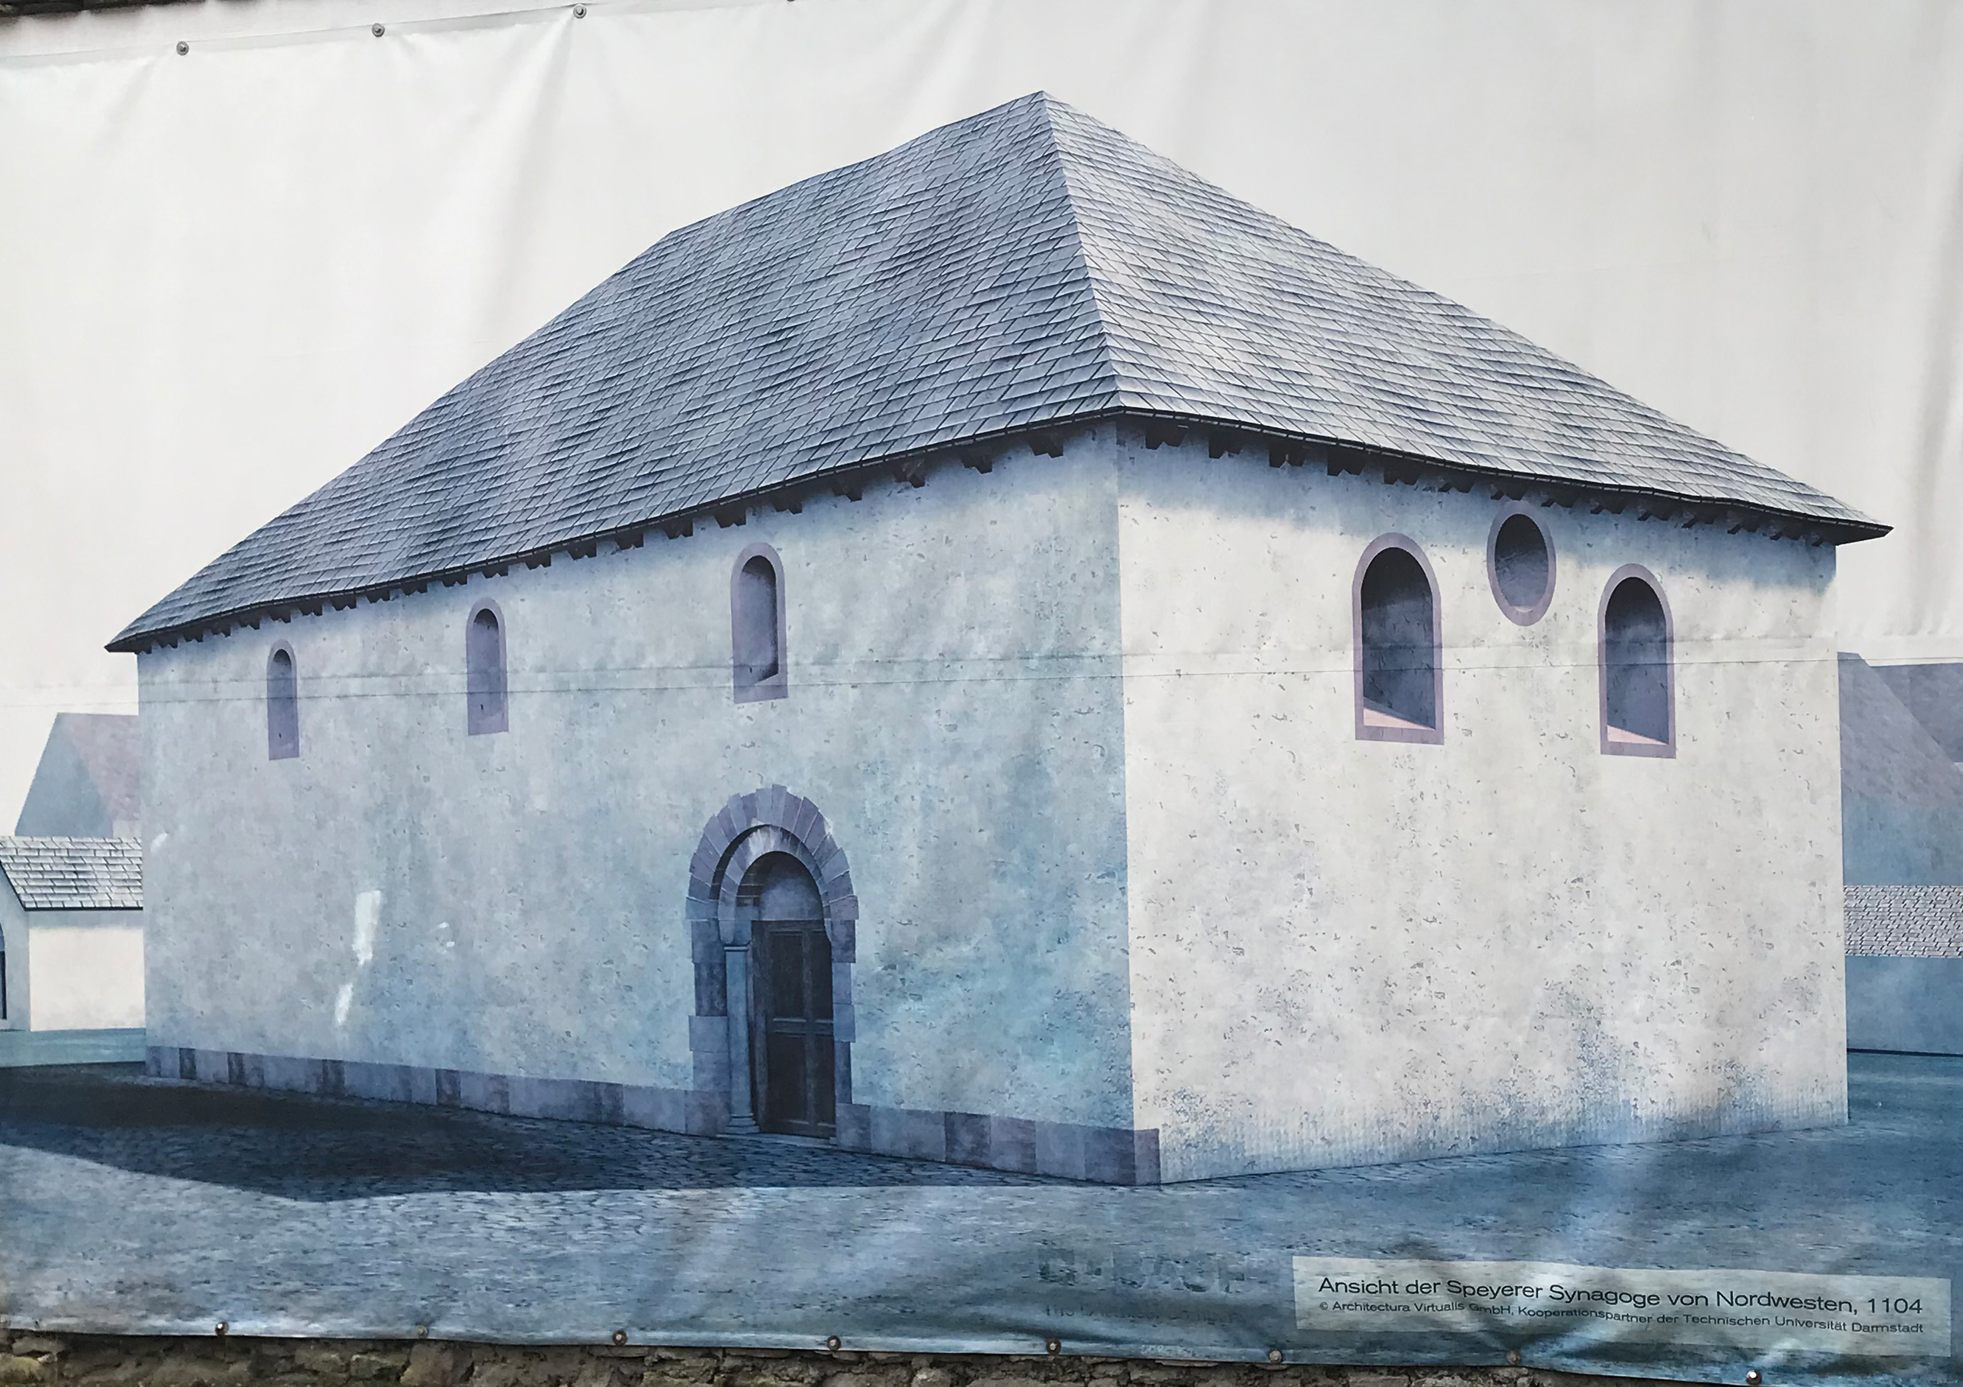
Uncertainty | There are some traces of the plinth, but they have to be mentally completed | 03-deduction

Floor

Reconstruction | 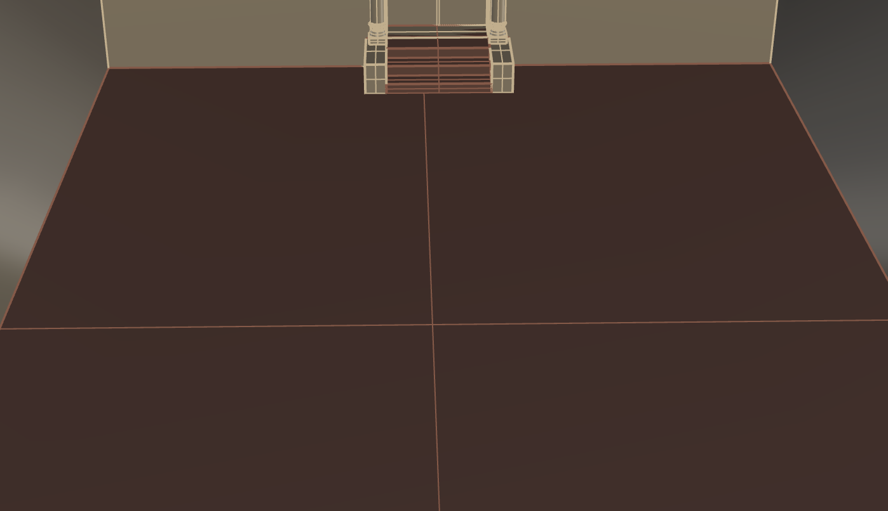
Used sources | reconstruction_01_rendering_02.png
Uncertainty | There are no traces of the ancient floor | 01-hypothesis

Foundations

Reconstruction | 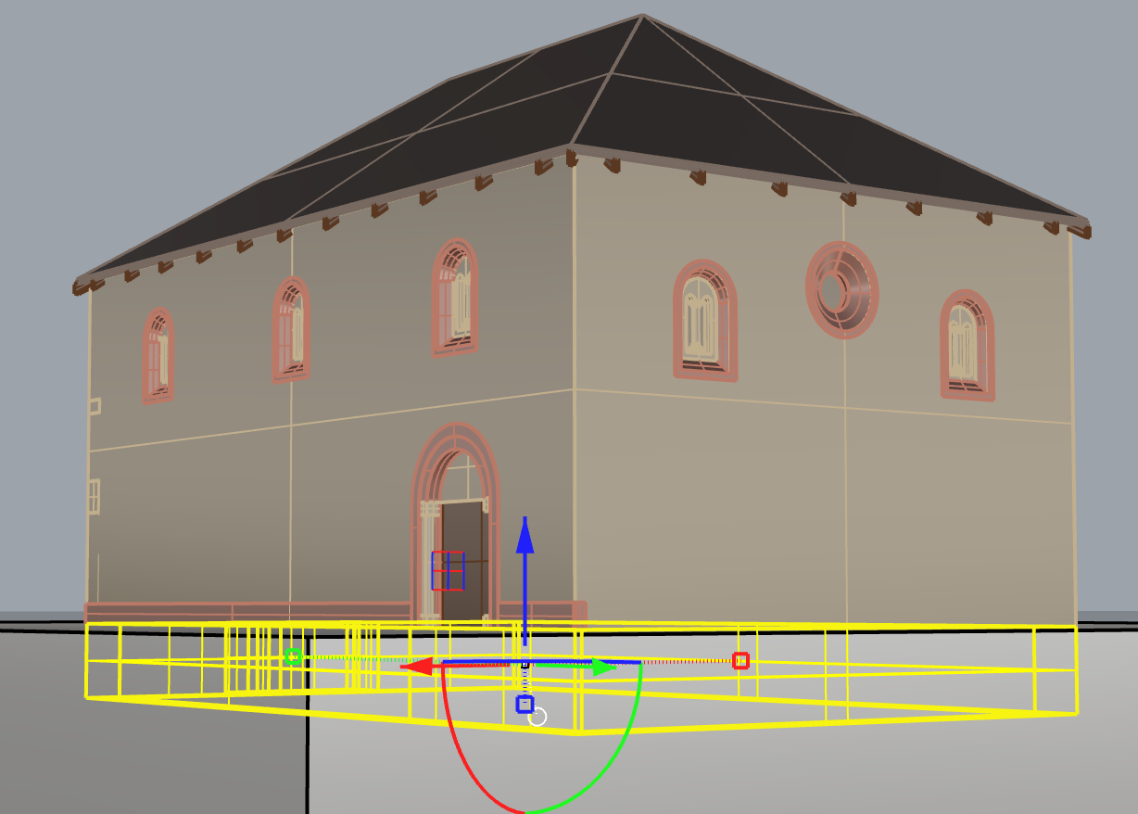
Used sources | report_05.jpg
Uncertainty | The foundations are still there and they were analysed during the archaeological excavations | 04-still existing

